ELECTROCHEMICAL METHODS
CONTENTS
INTRODUCTION
PRINCIPLE
IMPORTANT DEFINITIONS AND RELATIONS
MEASURMENT OF CONDCTIVITY
INSTRUMENTATION
CONDUCTOMETRIC TITRATIONS
ADVANTAGES AND DISADVANTAGES OF CONDUCTOMETRIC TITRATIONS
APPLICATIONS OF CONDUCTOMETRIC MEASURMENTS

Electrochemistry is branch of chemistry concern with the interaction of electrical and chemical effects. A large part of this field deals with the study of chemical changes caused by the passage of an electrical current and the production of electrical energy by chemical reaction.
The named electrochemistry because its originated from the study of the movement of electrons in an oxidation–reduction reaction. Electrochemical methods: are analytical techniques that use a measurement of potential, charge, or current to determine an analyte’s concentration or to characterize an analyte’s chemical reactivity.
It is a qualitative and quantitative methods of analysis based on electrochemical phenomena occurring within a medium or at the phase boundary and related to changes in the structure, chemical composition, or concentration of the compound being analyzed.These methods are divided into five major groups: potentiometry, voltammetry, coulometry, conductometry, and dielectrometry.
PRINCIPLE
Based on the conductance of electrical current through electrolyte solutions similar to metallic conductors.
The electric conductance in accordance with ohms law which states that the strength of current(I) passing through conductor is directly proportional to potential difference and inversely to resistance. I=V/R
where I = strength of current
V= potential difference
R= resistance

DEFINITIONS
Ohms law: According to this law, the strength of current (I) flowing through a conductor is directly proportional to the potential difference (E) applied across the conductor and inversely proportional to the resistance (R) of the conductor.
I = E/R
Conductance: It implies the ease with which the current flows through conductor, thus the conductance is reciprocal to resistance.
C= I/R
MEASUREMENT OF CONDUCTANCE
It has already been seen that the measurement of conductance is a measurement of resistance, the Wheatstone bridge method can, therefore, be used for its measurement.
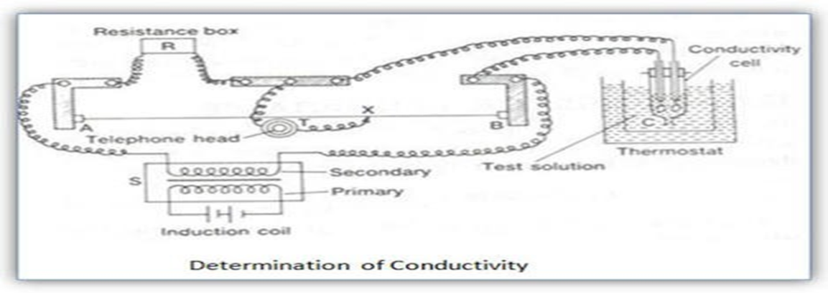
What is Titration?
A quantitative and volumetric technique, to determine the unknown concentration of a solution by the known concentration of a solution in the presence of indicator is called Titration.
Titration is a common laboratory method of using quantitative chemical analysis. This method is used to determine the unidentified concentration of a known analyte. The volume measurement is known as volumetric analysis, and it is important in the titration.
Types of Titration
There are many types of titration when considering goals and procedures. However, the most common types of titration in quantitative chemical analysis are redox titration and acid-base titration.
Acid-base Titrations , Redox Titrations, Precipitation Titrations, Complexometric Titrations.

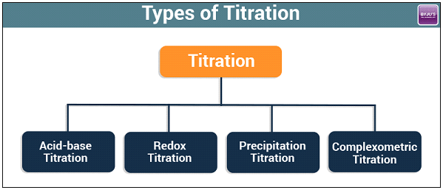

Conductometry is a measurement of electrolytic conductivity to monitor a progress of chemical reaction. Conductometry has notable application in analytical chemistry, where conductometric titration is a standard technique.
Conductometric titration: In this method we determine the point where reaction is completed with the help of a conductometer that measures the changes in conductance of solution produced by the ions in the solution. This point at which this transition occurs is called Equivalence point.
At Equivalence point we measure the volume of base used to neutralize the acid ions completely in the solution. Putting these values in formula we can get the strength of acid.
The principle of conduct metric titration is based on the fact that during the titration, one of the ions is replaced by the other and invariably these two ions differ in the ionic conductivity with the result that conductivity of the solution varies during the course of titration. The equivalence point may be located graphically by plotting the change in conductance as a function of the volume of titrant added.
1-Strong Acid with a Strong Base: e.g. HCl with NaOH:
HCl + NaOH → NaCl + H2O
Na+ + OH- → Na+ + Cl- + H2O
Before titration the conductance is high which is due to HCl→ H+ + Cl- mobility of H+ is 350 and that of Cl- ion is 73. Upon addition of NaOH the H+ ion reacts with OH- ion to form the very weakly ionized water molecule. This means that the H+ ion is removed from the medium and replaced by Na+ ion which has a mobility of 43; thus a continuous abrupt decrease in conductance occurs during the titration till the end point. Beyond the end point there is excess Na+ and OH- ions with 43 and 198 mobility due to continuous addition of NaOH So there is continuous increase in conductance and the curve will have a V shape , the end point is the minimum of the curve.
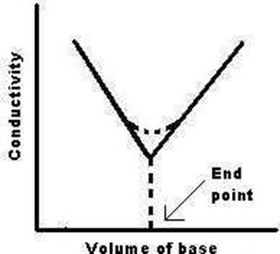
Conductometric titration of a strong acid (HCl) vs. a strong base(NaOH) .
2. Weak Acid with a Strong Base, e.g. acetic acid with NaOH:
CH3COOH + Na+ + OH- → CH3COO- + Na+ + H2O
Before titration low initial conductance is observed due to low H⁺ obtained during dissociation of weak CH3COOH.During titration we can observe slight decrease of conductance due to consumption of H⁺. During progress of titration we can observe slight increase in conductance due to the presence of CH3COO- and Na⁺ and nearly constant H⁺ due to the buffer action of the produced CH3COONa and the remaining CH3COOH. After end point excess NaOH will lead to increase in conductance due to increasing of Na⁺ and OH⁻ .

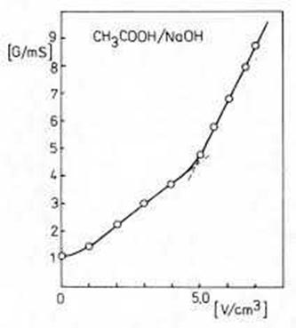
Conductometric titration of a weak acid (acetic acid) vs. a strong base (NaOH).
3. Strong Acid with a Weak Base, e.g. sulphuric acid with dilute ammonia:
Initially the conductance is high and then it decreases due to the replacement of H+. But after the endpoint has been reached the graph becomes almosthorizontal, since the excess aqueous ammonia is not appreciably ionised in the presence of ammonium sulphate.
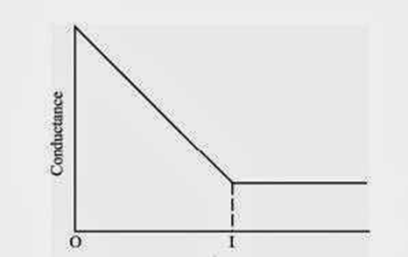
Conductometric titration of a strong acid (H2SO4) vs. a weak base(NH4OH).
4. Weak Acid with a Weak Base:
The nature of curve before the equivalence point is similar to the curve obtained by titrating weak acid against strong base. After the equivalence point, conductance virtually remains same as the weak base which is being added is feebly ionized and, therefore, is not much conducting.
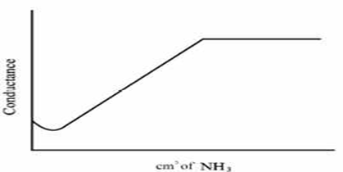
Conductometric titration of a weak acid (acetic acid) vs. a weak base (NH4OH).

5. Mixture of a Strong Acid and a Weak Acid vs. a Strong Base or a Weak Base: The initial conductivity is high it is due to HCl which by common ion effect suppress the ionization of H3COOH. Upon titration; decrease in conductivity occurs due to replacement of H+ ion with mobility 350
by Na+ ion with mobility 43 , till all the H+ ions from HCl are neutralized.CH3COOH will thus ionize and react with NaOH.The change in conductivity will take place in similar way as described above.
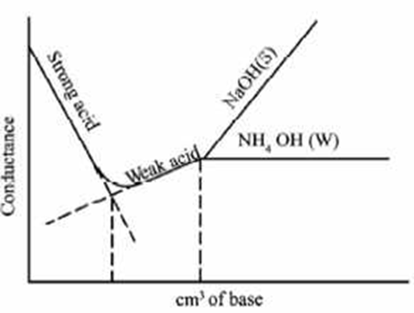
Conductometric titration of a mixture of a strong acid (HCl) and a weak acid (CH3COOH) vs. a strong base (NaOH) or a weak base (NH4OH).
ADVANTAGES OF CONDUCTOMETRIC TITRATIONS
- Does not require indicators since change in conductance is measured by conducto -meter.
- Suitable for colored solutions.
- Since end point is determined by graphically means accurate results are obtained with minimum error.
- Used for analysis of turbid suspensions, weak acids, weak bases, mix of weak and strong acids.
- Temperature is maintained constant throughout the titration.
- This method cab be used with much diluted solutions.
- Be seen by eye.

DISADVANTAGES

- Increased levels of salt in solutions masks the conductivity changes in such cases it does not gives accurate results.
- Applications of conduct metric titrations to redox systems is limited because, high concentration of hydronium ions in the solutions tends to mask the change in conductance.

APPLICATIONS
- Applications obtaining thermodynamic data about a reaction.
- To generate an unstable intermediate such as radical ion and study its rate of decay or it is spectroscopic properties.
- They use to analyze a solution for trace amount of metal ions or organic species.
- The electrochemical properties of the system themselves are of primary interest, for example, in the design of a new power source or for the electrochemical methods have been developed.

