This article provides information about the Idea of Auguste Comte on the Change Development and Progress of Human Society:
August Comte, the founding father of sociology focused his attention on the study of change, development and progress in human society. He divided the study of society into two parts: social statics and social dynamics. Comte saw human society and history as a single entity. Moreover, he regarded the history of Europe as synonymous with the history, of the human race. Accordingly he made several generalizations.
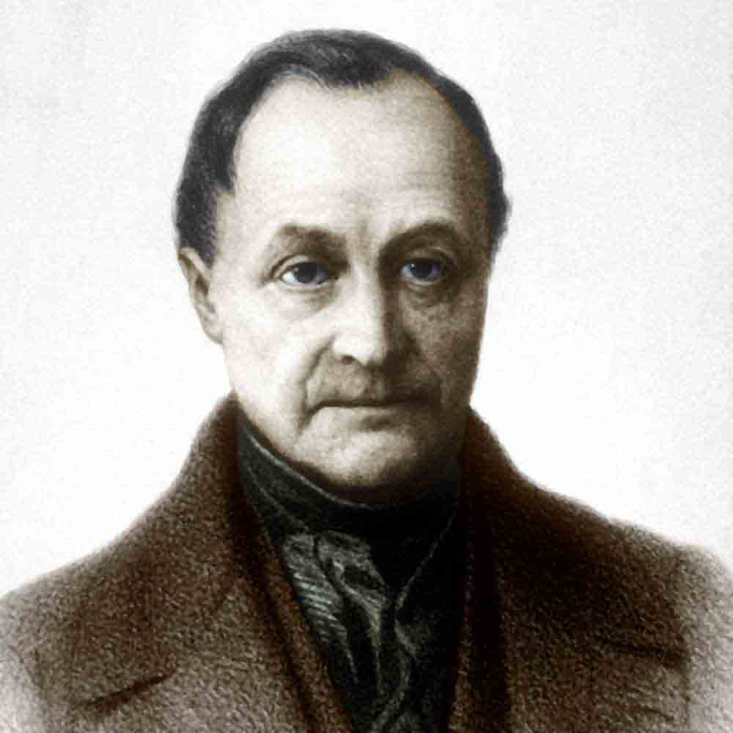
Comte observed that certain types of societies were dying and others were being born. The dying types were the theological and military. Medieval society was united by transcendent faith as expounded by the Catholic Church. Theological thinking was contemporaneous with the predominance of military activity, which was expressed by the fact that the highest rank was granted to warriors.
The type being born was scientific and industrial. In this society, the scientists replaced the theologians; and the industrialists, businessmen, managers and financers replaced the warriors. Indeed from the moment man related thinking scientifically, the chief activity of collectivities ceases to be the war of man against man and becomes the struggle of man against nature, the systematic exploitation of natural resources.
Comte gave a universal scope and a deeper meaning to the idea of progress when he expounded the law of three stages of human evolution. To him, the human mind passes through three stages of progression theological, metaphysical and positive. In the theological stage human beings explain phenomena by ascribing them to beings or forces comparable to humans themselves.
In the metaphysical stage human beings explain phenomena in terms of nature; in the positive scientific stage man examines the phenomena and their linkages are examined in terms of reasoning. “To Comte, the method that triumphed in mathematics, astronomy, physics, chemistry and biology must eventually prevail in politics and culminate in the founding of a positive science of society that is called sociology.”
When Auguste Comte defined sociology as the science of order and progress, and divided it into social statics (order) and social dynamics (progress), he was in fact inferring that progress was possible through order. He tried to understand social changes that occurred in the early years of the industrial revolution as an evolutionary process.
The theory of evolution explains that societies pass through a number of stages starting from a simple form and becoming more complex as the process of evolution progresses. In the same way, Auguste Comte put forward the idea of evolutionary change and also related the idea of progressive change to the development of intellect, in particular the development of scientific thought.
This “law of three stages” postulates that intellectual progress is accompanied by moral development, with a number of changes in social institutions as well. Comte considered material as well as moral progress to be essential types of progress and social change as a product of internal forces, that too, in a linear form.

