High-Performance Liquid Chromatography (HPLC) Notes

Table of Contents

Principle of High-Performance Liquid Chromatography (HPLC)

Instrumentation of High-Performance Liquid Chromatography (HPLC)

Types of High-Performance Liquid Chromatography (HPLC)

Applications of High-Performance Liquid Chromatography (HPLC)

Advantages of High-Performance Liquid Chromatography (HPLC)

[Limitations](https://microbenotes.com/high-performance-liquid-chromatography-hplc/#limitations)

[References](https://microbenotes.com/high-performance-liquid-chromatography-hplc/#references)

High-Performance Liquid Chromatography (HPLC)

* High performance liquid chromatography or commonly known as HPLC is an analytical technique used to separate, identify or quantify each component in a mixture.
* The mixture is separated using the basic principle of column [**chromatography**](https://microbenotes.com/chromatography-principle-types-and-applications/) and then identified and quantified by spectroscopy.
* In the 1960s the column chromatography LC with its low-pressure suitable glass columns was further developed to the HPLC with its high-pressure adapted metal columns.
* HPLC is thus basically a highly improved form of column liquid chromatography. Instead of a solvent being allowed to drip through a column under gravity, it is forced through under high pressures of up to 400 atmospheres.

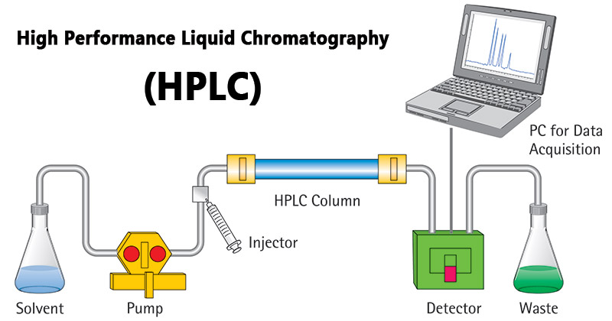

Principle of High-Performance Liquid Chromatography (HPLC)

• The purification takes place in a separation column between a stationary and a mobile phase.

• The stationary phase is a granular material with very small porous particles in a separation column.

• The mobile phase, on the other hand, is a solvent or solvent mixture which is forced at high pressure through the separation column.

• Via a valve with a connected sample loop, i.e. a small tube or a capillary made of stainless steel, the sample is injected into the mobile phase flow from the pump to the separation column using a syringe.

• Subsequently, the individual components of the sample migrate through the column at different rates because they are retained to a varying degree by interactions with the stationary phase.

• After leaving the column, the individual substances are detected by a suitable detector and passed on as a signal to the HPLC software on the computer.

• At the end of this operation/run, a chromatogram in the HPLC software on the computer is obtained.

• The chromatogram allows the identification and quantification of the different substances.

Instrumentation (HPLC)

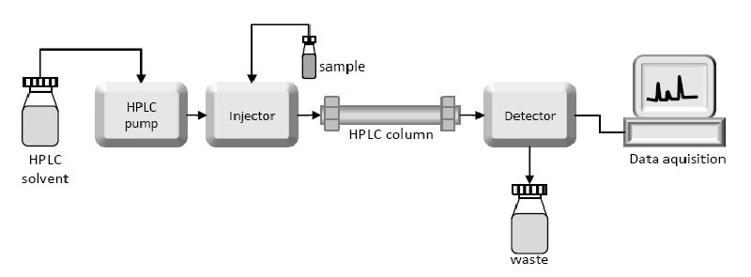

**The Pump**

* The development of HPLC led to the development of the pump system.
* The pump is positioned in the most upper stream of the liquid chromatography system and generates a flow of eluent from the solvent reservoir into the system.
* High-pressure generation is a “standard” requirement of pumps besides which, it should also to be able to provide a consistent pressure at any condition and a controllable and reproducible flow rate.
* Most pumps used in current LC systems generate the flow by back-and-forth motion of a motor-driven piston (reciprocating pumps). Because of this piston motion, it produces “pulses”.

**Injector**

* An injector is placed next to the pump.
* The simplest method is to use a syringe, and the sample is introduced to the flow of eluent.
* The most widely used injection method is based on sampling loops.
* The use of the auto sampler (auto-injector) system is also widely used that allows repeated injections in a set scheduled-timing.

**Column**

* The separation is performed inside the column.
* The recent columns are often prepared in a stainless steel housing, instead of glass columns.
* The packing material generally used is silica or polymer gels compared to calcium carbonate.  
  The eluent used for LC varies from acidic to basic solvents.
* Most column housing is made of stainless steel since stainless is tolerant towards a large variety of solvents.

**Detector**

* Separation of analytes is performed inside the column, whereas a detector is used to observe the obtained separation.
* The composition of the eluent is consistent when no analyte is present. While the presence of analyte changes the composition of the eluent. What detector does is to measure these differences.
* This difference is monitored as a form of an electronic signal. There are different types of detectors available.

**Commonly used detectors in HPLC**

* 1. UV, VIS, and PDA Detector
  2. Refractive-Index Detector
  3. Fluorescence Detector
  4. Electro Chemical Detector

**Type** **Common used Abbreviation**

Ultra Violet UV

Visible VIS

Photo Diode Array PDA

Refractive Index RI

Fluorescence FL

Electro Chemical EC

* 1. **UV, VIS, and PDA Detectors**

The UV, VIS, and PDA detectors are categorized as absorbance detectors. They provide good sensitivity for light-absorbing compounds at ~pg level. They are easy to operate and provide good stability. UV detector is a very commonly used detector for HPLC analysis. During the analysis, sample goes through a clear color-less glass cell, called flow cell. When UV light is irradiated on the flow cell, sample absorbs a part of UV light. Thus, the intensity of UV light observed for the mobile phase (without sample) and the eluent containing sample will differ. By measuring this difference, the amount of sample can be determined. Since the UV absorbance also differs depend on what wavelength is used, it is important to choose an appropriate wavelength based on the type of analyte. A standard UV detector allows user to choose wavelength between 195 to 370 nm. Most commonly used is 254 nm. Compared to a UV detector, a VIS detector uses longer wavelength (400 to 700 nm). There are detectors that provide wider wavelength selection, covering both UV and VIS ranges (195 to 700 nm) called UV/VIS detector.  
PDA detects an entire spectrum simultaneously. UV and VIS detectors visualize the obtained result in two dimensions (light intensity and time), but PDA adds the third dimension (wavelength). This is convenient to determine the most suitable wavelength without repeating analyses.

**2. Refractive-Index Detector**

RI detector measures change in reflex index. A glass cell is divided into two chambers (cells). The effluent from LC column flow through the "sample cell", while other cell called "reference cell" is filled with only mobile phase. When the effluent going through the sample cell does not contain any analyte, the solvent inside both cells are the same (Figure 1A). When a beam is irradiate on the cells, the observed beam will be straight in this case. However, in a case the effluent contains any components other than mobile phase; bending of the incident beam occurs due to the reflex index difference between the two solvents (Figure 1B). By measuring this change, the presence of components can be observed. RI detector has lower sensitivity compared to UV detector, and that's the main reason why RI is not as commonly used as UV. However, there are some advantages over UV detector.

* It is suitable for detecting all components. For an example, samples which do not have UV absorption, such as sugar, alcohol, or inorganic ions obviously cannot be measured by a UV detector. In contrast, change in reflective index occurs for all analyte, thus a RI detector can be used to measure all analyte.
* It is applicable for the use with solvent that has UV absorbance. A UV detector cannot be used with solvent which has UV absorbance. Sometimes the organic solvent used for GPC analysis absorbs UV, and thus UV detector cannot be used.
* It provides a direct relationship between the intensity and analyte concentration. The amount of UV absorbed depends on each analyte, thus the intensity of UV detector peak does not provide information on the analyte concentration. While intensity observed by a RI detector is comparable to the concentration of analyte. Because of those advantages, RI is often used for the detection of sugars and for SEC analysis.

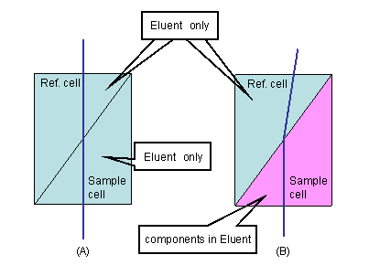

**c. Fluorescence Detector**

The advantage of fluorescence method is its high sensitivity for selective groups of compounds at ~fg level. By using a specific wavelength, analyte atoms are excited and then emit light signal (fluorescence). The intensity of this emitted light is monitored to quantify the analyte concentration. Most pharmaceuticals, natural products, clinical samples, and petroleum products have fluorescent absorbance. For some compounds which do not have fluorescence absorbance or low absorbance, they can be treated with fluorescence derivatives such as dansylchloride. The system is easy to operate and relatively stable.

**d. Electro Chemical Detector**

There are several different types of ECs. The detection is based on amperometry, polarography, coulometry, and conductrometry. They offer high sensitivity, simplicity, convenience, and wide-spread applicability. It is especially suitable for the use with semi-micro or capillary type system.

**e. Conductivity Detector**

Solutions containing ionic components will conduct electricity. Conductivity detector measures electronic resistance and measured value is directly proportional to the concentration of ions present in the solution. Thus it is generally used for ion chromatography.

**Recorder**

* The change in eluent detected by a detector is in the form of an electronic signal, and thus it is still not visible to our eyes.
* In older days, the pen (paper)-chart recorder was popularly used. Nowadays, a computer-based data processor (integrator) is more common.
* There are various types of data processors; from a simple system consisting of the in-built printer and word processor while those with software that are specifically designed for an LC system which not only data acquisition but features like peak-fitting, baseline correction, automatic concentration calculation, molecular weight determination, etc.

**Degasser**

The eluent used for LC analysis may contain gases such as oxygen that are non-visible to our eyes.

* When gas is present in the eluent, this is detected as noise and causes an unstable baseline.
* Degasser uses special polymer membrane tubing to remove gases.
* The numerous very small pores on the surface of the polymer tube allow the air to go through while preventing any liquid to go through the pore.

**Column Heater**

The LC separation is often largely influenced by the column temperature.

* In order to obtain repeatable results, it is important to keep consistent temperature conditions.
* Also for some analysis, such as sugar and organic acid, better resolutions can be obtained at elevated temperatures (50 to 80°C).
* Thus columns are generally kept inside the column oven (column heater).

Types of High-Performance Liquid Chromatography (HPLC)

1. **Normal phase:**

Column packing is polar (e.g silica) and the mobile phase is non-polar. It is used for water-sensitive compounds, geometric isomers, cis-trans isomers, and chiral compounds.

1. **Reverse phase:**

The column packing is non-polar (e.g C18), the mobile phase is water+  miscible solvent (e.g methanol). It can be used for polar, non-polar, ionizable and ionic samples.

1. **Ion exchange:**

Column packing contains ionic groups and the mobile phase is buffer. It is used to separate anions and cations.

1. **Size exclusion:**

Molecules diffuse into pores of a porous medium and are separated according to their relative size to the pore size. Large molecules elute first and smaller molecules elute later

**Applications of High-Performance Liquid Chromatography (HPLC)**

The HPLC has developed into a universally applicable method so that it finds its use in almost all areas of chemistry, biochemistry, and pharmacy.

* Analysis of drugs
* Analysis of synthetic polymers
* Analysis of pollutants in environmental analytics
* Determination of drugs in biological matrices
* Isolation of valuable products
* Product purity and quality control of industrial products and fine chemicals
* Separation and purification of biopolymers such as enzymes or nucleic acids
* Water purification
* Pre-concentration of trace components
* Ligand-exchange chromatography
* Ion-exchange chromatography of proteins
* High-pH anion-exchange chromatography of carbohydrates and oligosaccharides

Advantages of High-Performance Liquid Chromatography (HPLC)

1. Speed
2. Efficiency
3. Accuracy
4. Versatile and extremely precise when it comes to identifying and quantifying chemical components.

Limitations

• **Cost:**Despite its advantages, HPLC can be costly, requiring large quantities of expensive organics.

• **Complexity**

• HPLC does have **low sensitivity** for certain compounds, and some cannot be detected as they are irreversibly adsorbed.

• Volatile substances are better separated by gas chromatography.

References

1. <https://www.shodex.com/en/kouza/a.htmlr>
2. <https://www.alphacrom.com/en/hplc-basics>
3. <https://laboratoryinfo.com/hplc/>
4. <https://sciencing.com/disadvantages-advantages-hplc-5911530.html>
5. https://www.chemguide.co.uk/analysis/chromatography/hplc.html
6. https://www.azom.com/article.aspx?ArticleID=8468
7. https://www.ru.ac.za/media/rhodesuniversity/content/nanotechnology/documents/chromatography%20Augustus.pdfReferences
8. Analytical Chemistry 7th (Seventh) Edition by Skoog 2006