**Good Governance**

In 1994 World Bank defined **good governance** as representing “predictable, enlightened and open policy processes, bureaucracy with professional ethos (attitude), a government accountable for its‟ actions, a strong civil society participating actively in public affairs and all under the rule of law”. Thus, World Bank was/is mainly concerned with economic development.

Good governance in this sense implies the efficiency of the state to manage its resources in a way that results in economic development. The World Bank “By helping to fight corruption, improve transparency and accountability in governance, strengthen judicial systems and modernize financial sectors, the bank contributes to building environments in which people are better able to pursue a broader range of human rights.

Thus, the focus of good governance shifted from economic development and better management of resources to an equal emphasis on elements of accountability, transparency and efficiency, ensuring an environment in which people could enjoy their rights. The good governance now clearly includes social and political development as well. The public bodies are expected to transfer the benefits of development to the masses. The various contents of the concept of good governance like accountability, transparency, responsiveness require the governance to be more decentralized and linked to the peoples‟ rights.

**Elements/ Characteristics of Good governance**

Good Governance has eight (8) characteristics such as, participatory, consensus oriented, accountable, transparent, responsive, effective and efficient, equitable and inclusive and follows the rule of law. It assures that corruption is minimized, the views of minorities are taken into account and that the voices of the most vulnerable in society are heard in decision-making. It is also responsive to the present and future needs of society.

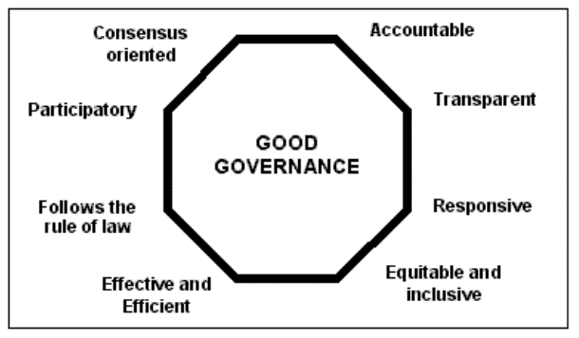

* **Participation**

Participation by both men and women is a key cornerstone of good governance.

Participation could be either direct or through legitimate intermediate institutions or representatives. It is important to point out that representative democracy does not necessarily mean that the concerns of the most vulnerable in society would be taken into consideration in decision making.

Participation needs to be informed and organized. This means freedom of association and expression on the one hand and an organized civil society on the other hand.

* **Rule of law**

Good governance requires fair legal frameworks that are enforced impartially. It also requires full protection of human rights, particularly those of minorities. Impartial enforcement of laws requires an independent judiciary and an impartial and incorruptible police force.

* **Transparency**

Transparency means that decisions taken and their enforcement are done in a manner that follows rules and regulations. It also means that information is freely available and directly accessible to those who will be affected by such decisions and their enforcement. It also means that enough information is provided and that it is provided in easily understandable forms and media.

* **Responsiveness**

Good governance requires that institutions and processes try to serve all stakeholders within a reasonable timeframe.

* **Consensus oriented**

There are several actors and as many viewpoints in a given society. Good governance requires mediation of the different interests in society to reach a broad consensus in society on what is in the best interest of the whole community and how this can be achieved. It also requires a broad and long-term perspective on what is needed for sustainable human development and how to achieve the goals of such development. This can only result from an understanding of the historical, cultural and social contexts of given society or community.

* **Equity and inclusiveness**

A society’s well-being depends on ensuring that all its members feel that they have a stake in it and do not feel excluded from the mainstream of society. This requires all groups, but particularly the most vulnerable, have opportunities to improve or maintain their well-being.

* **Effectiveness and efficiency**

Good governance means that processes and institutions produce results that meet the needs of society while making the best use of resources at their disposal. The concept of efficiency in the context of good governance also covers the sustainable use of natural resources and the protection of the environment.

* **Accountability**

Accountability is a key requirement of good governance. Not only governmental institutions but also the private sector and civil society organizations must be accountable to the public and to their institutional stakeholders. Who is accountable to whom varies depending on whether decisions or actions taken are internal or external to an organization or institution. In general an organization or an institution is accountable to those who will be affected by its decisions or actions.

Accountability cannot be enforced without transparency and the rule of law.

**How to achieve good governance**

Good governance, to be effective and sustainable, must be anchored in a vigorous working democracy which respects the rule of law, a free press, energetic civil society organizations and effective and independent public bodies such as the Commission for Human Rights and Good Governance, Prevention of Corruption Bureau and the Fair Trade Commission. The Commission is important in ensuring the promotion and protection of human rights, but also in ensuring both transparency and accountability on the part of the government. Good governance requires transparency and efficiency also in different government agencies.

At the political level democratic practices, including transparency in policy making and administration, are important aspects of good governance. This is signified by a pluralistic political system that allows the existence of diversity in political and ideological opinions. No wonder that good governance is said to be more easily achieved and guaranteed in a multi-party system than in a mono-party system. It also means the holding of regular elections applying the principle of universal franchise. In order to qualify as democratic, elections must be free and fair.

Good governance deals with the nature and limits of state power. The doctrine of the separation of powers is therefore relevant in the establishment of whether or not a country has a political system that is responsive to good governance. The doctrine of the separation of powers is based on the acceptance that there are three main categories of government functions: legislative, executive, and judicial. Corresponding to these are the three main organs of government in a state – the Legislature, the Executive and the Judiciary. The doctrine insists that these three powers and functions of government in a free democracy must be kept separate and exercised by separate organs of the state.

**Conclusion**

From the above discussion it should be clear that good governance is an ideal which is difficult to achieve in its totality. Very few countries and societies have come close to achieving good governance in its totality. However, to ensure sustainable human development, actions must be taken to work towards this ideal with the aim of making it a reality.