Radioactivity and Nuclear Chemistry

* Introduction
* Major Forms of Radioactivity
* Alpha Particle (α)
* Beta Particle (β)
* Gamma Radiation (γ)
* Positron Emission (β+ decay) and Electron Capture
* Nuclear Fission
* Radioactive Half Lives
* Measurement of radioactivity
* Biological Effects of Radiation Exposure
* Uses of Radioactive Isotopes
* References

Radioactivity and Nuclear Chemistry

Atomic theory in the nineteenth century presumed that nuclei had fixed compositions. But in 1896, the French scientist Henri Becquerel found that a uranium compound placed near a photographic plate made an image on the plate, even if the compound was wrapped in black cloth. He reasoned that the uranium compound was emitting some kind of radiation that passed through the cloth to expose the photographic plate. Further investigations showed that the radiation was a combination of particles and electromagnetic rays, with its ultimate source being the atomic nucleus. These emanations were ultimately called, collectively, radioactivity.

Following the somewhat serendipitous discovery of radioactivity by Becquerel, many prominent scientists began to investigate this new, intriguing phenomenon. Among them were Marie Curie who was the first to coin the term “radioactivity”.

Ernest Rutherford, who investigated and named three of the most common types of radiation. During the beginning of the twentieth century, many radioactive substances were discovered, the properties of radiation were investigated and quantified, and a solid understanding of radiation and nuclear decay was developed.

The spontaneous change of an unstable nuclide into another is radioactive decay. The unstable nuclide is called the parent nuclide; the nuclide that results from the decay is known as the daughter nuclide. The daughter nuclide may be stable, or it may decay itself. The radiation produced during radioactive decay is such that the daughter nuclide lies closer to the band of stability than the parent nuclide, so the location of a nuclide relative to the band of stability can serve as a guide to the kind of decay it will undergo (Figure 3.1).

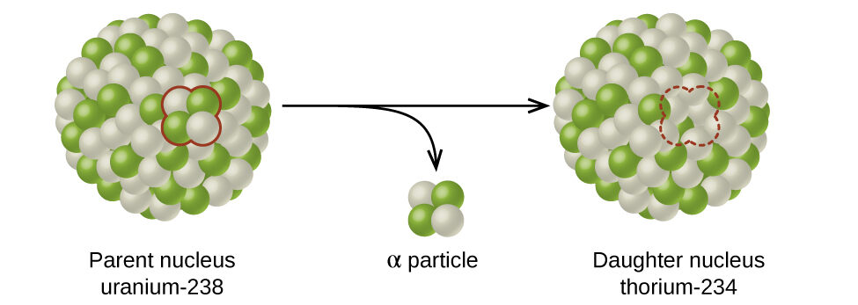

Figure 3.1 A nucleus of uranium-238 (the parent nuclide) undergoes α decay to form thorium-234 (the daughter nuclide). The alpha particle removes two protons (green) and two neutrons (gray) from the uranium-238 nucleus.

Major Forms of Radioactivity

Alpha Particle (α)

Rutherford’s experiments demonstrated that there are three main forms of radioactive emissions. The first is called an alpha particle, which is symbolized by the Greek letter α. An alpha particle is composed of two protons and two neutrons and is the same as a helium nucleus. (We often use 24He to represent an alpha particle.) It has a 2+ charge. When a radioactive atom emits an alpha particle, the original atom’s atomic number decreases by two (because of the loss of two protons), and its mass number decreases by four (because of the loss of four nuclear particles). We can represent the emission of an alpha particle with a chemical equation-for example, the alpha-particle emission of uranium-235 is as follows:

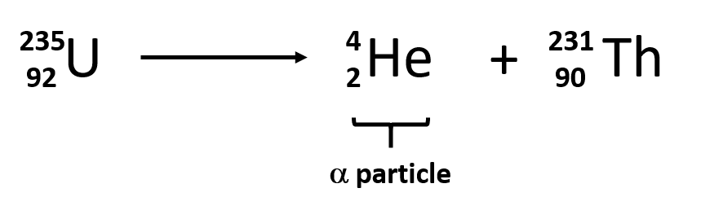

We use the law of conservation of matter, which says that matter cannot be created or destroyed. This means we must have the same number of protons and neutrons on both sides of the nuclear equation. If our uranium nucleus loses 2 protons, there are 90 protons remaining, identifying the element as thorium. Moreover, if we lose four nuclear particles of the original 235, there are 231 remaining. Thus we use subtraction to identify the isotope of the The atom- in this case, 231Th90.

Beta Particle (β)

The second type of radioactive emission is called a beta particle, which is symbolized by the Greek letter β. A beta particle is an electron ejected from the nucleus (not from the shells of electrons about the nucleus) and has a -1 charge. We can also represent a beta particle as -10e. The net effect of beta particle emission on a nucleus is that a neutron is converted to a proton. The overall mass number stays the same, but because the number of protons increases by one, the atomic number goes up by one. Carbon-14 decays by emitting a beta particle:

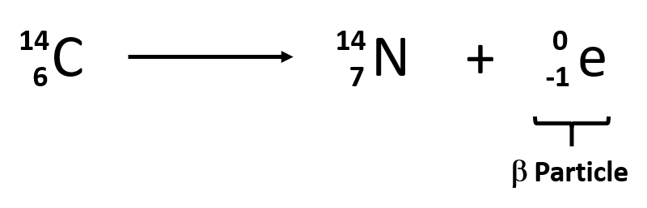

Again, the sum of the atomic numbers is the same on both sides of the equation, as is the sum of the mass numbers. (Note that the electron is assigned an “atomic number” of –1, equal to its charge.)

Gamma Radiation (γ)

The third major type of radioactive emission is not a particle but rather a very energetic form of electromagnetic radiation called gamma rays, symbolized by the Greek letter γ. Electromagnetic radiation can be characterized into different categories based on the wavelength and photon energies. The electromagnetic spectrum shown in figure 3.2 shows the major categories of electromagnetic radiation. Note that the human sensory adaptations of sight and hearing have evolved to detect electromagnetic radiation, with radio waves having wavelengths between 1 mm and 100 km and visible light having wavelengths between 380-700 nm. Technological advances have helped humankind utilize other forms of electromagnetic radiation including X-rays and microwaves.

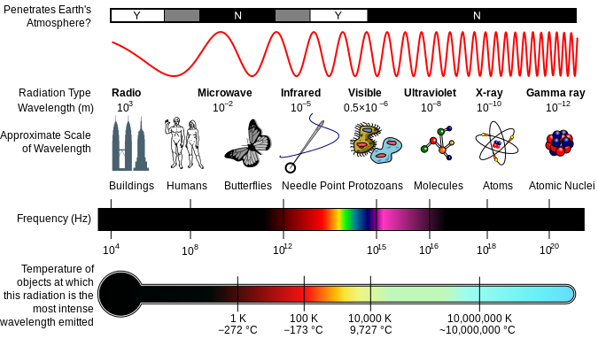

Figure 3.2 The Electromagnetic Spectrum. A diagram of the electromagnetic spectrum, showing various properties across the range of frequencies and wavelengths.

Some electromagnetic radiation with very short wavelengths are active enough that they may knock out electrons out of atoms in a sample of matter and make it electrically charged. The types of radiation that can do this are termed ionizing radiation. X-rays and Gamma rays are examples of ionizing radiation. Some radioactive materials, emit gamma radiation during their decay. For example, in the decay of radioactive technetium-99, a gamma ray is emitted. Note that in radioactive decay where the emission of gamma radiation occurs, that the identity of the parent material does not change, as no particles are physically emitted.

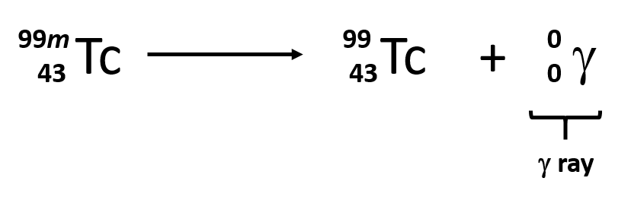

Sometimes the radioactive decay of a sample can result in the release of multiple forms of radioactivity. For example, in the radioactive decay of radon-222, both alpha and gamma radiation are emitted, with the latter having an energy of 8.2 × 10−14 J per nucleus decayed:

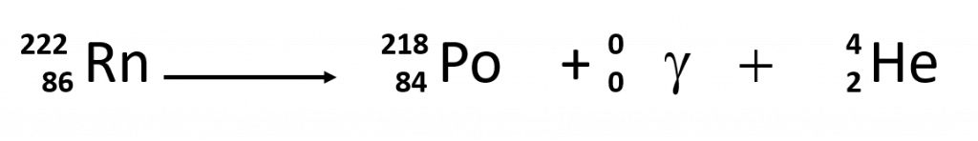

Table 3.1 The Three Main Forms of Radioactive Emissions

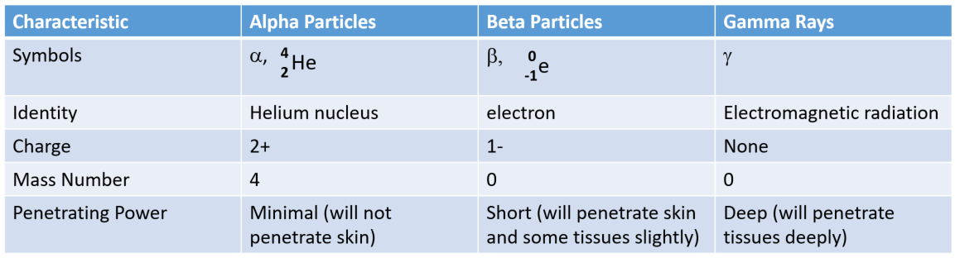

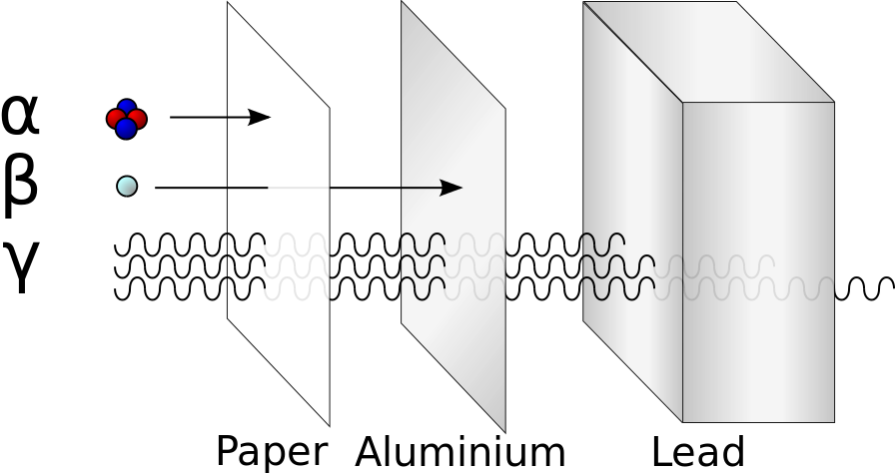

Figure 3.3 Illustration of the relative abilities of three different types of ionizing radiation to penetrate solid matter. Typical alpha particles (α) are stopped by a sheet of paper, while beta particles (β) are stopped by an aluminum plate. Gamma radiation (γ) is damped when it penetrates lead.

Radioactive Half Lives

Each radioactive nuclide has a characteristic, constant half-life (t1/2), the time required for half of the atoms in a sample to decay. An isotope’s half-life allows us to determine how long a sample of a useful isotope will be available, and how long a sample of an undesirable or dangerous isotope must be stored before it decays to a low-enough radiation level that is no longer a problem.

For example, cobalt-60, an isotope that emits gamma rays used to treat cancer, has a half-life of 5.27 years (Figure 3.5). In a given cobalt-60 source, since half of the

nuclei decay every 5.27 years, both the amount of material and the intensity of the radiation emitted is cut in half every 5.27 years. Note that for a given substance, the intensity of radiation that it produces is directly proportional to the rate of decay of the substance and the amount of the substance. Thus, a cobalt-60 source that is used for cancer treatment must be replaced regularly to continue to be effective.

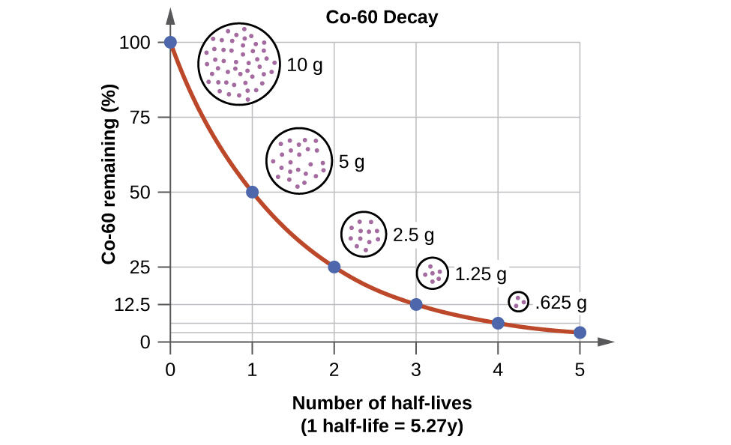

Figure 3.5. The Decay of Cobalt-60. For cobalt-60, which has a half-life of 5.27 years, 50% remains after 5.27 years (one half-life), 25% remains after 10.54 years (two half-lives), 12.5% remains after 15.81 years (three half-lives), and so on. Note that every half-life is the same length of time.

Biological Effects of Radiation Exposure

There is a large difference in the magnitude of the biological effects of nonionizing radiation (for example, light and microwaves) and ionizing radiation, emissions energetic enough to knock electrons out of molecules (for example, α and β particles, γ rays, X-rays, and high-energy ultraviolet radiation) (Figure 3.6).

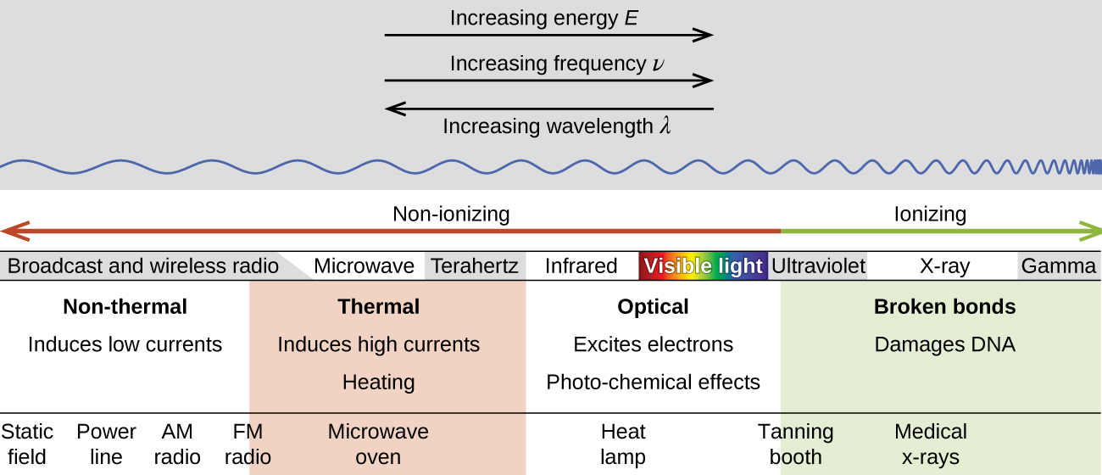

Figure 3.6. Damaging Effects of Ionizing Radiation. Lower frequency, lower-energy electromagnetic radiation is nonionizing, and higher frequency, higher-energy electromagnetic radiation is ionizing.

Uses of Radioactivy

* Food Sterilization
* Medical Applications and Radiotracers
* Smoke detectors
* Radiocarbon Dating
* Energy Production
* Weapons
* Food Sterilization
* Gamma irradiation of foods often from 60Co source
* Spices, herbs and dehydrated vegetables.
* Also poultry are also preserved in this way

Medical Applications of Radioactivity

Radiotracers

Radioactive nuclides can be introduced into laboratory reactions or organisms and traced

for diagnostic purposes. Renograms employ the use of tracers.

Infrared gun or Temperature gun. Used for quick body temperature measurements.

Radiation is also used in radiotherapy where higher doses of radiation are used to kill cancerous cells during the treatment of tumours.

The aim of radiation therapy is to cause damage to the cancerous cells whilst minimizing the risk to surrounding healthy tissue.

The damage inflicted by radiation therapy causes the cancerous cells to stop reproducing and thus the tumour shrinks.

The amount of radiation given to the patient has to be accurately calculated so that the damage is limited to the cancerous cells only.

Medical Scanners utilize many types of radiations

X-Rays – Bone structures opaque to rays

X-ray computed tomography (CT Scan-Xrays)

Magnetic Resonance Imaging (MRI – Nuclear magnetism)

Ultrasound (high frequency sound waves)

Positron Emission Tomography (PET Scan)

References

OpenStax . (2016) Nuclear Chemistry. Chemistry by Rice University is licensed under a Creative Commons Attribution 4.0 International Accessed, Dec 1st, 2018 from: