# Thin-layer chromatography

Thin-layer chromatography (TLC) is a chromatography technique used to separate non-volatile mixtures. Thin-layer chromatography is performed on a sheet of glass, plastic, or aluminum foil, which is coated with a thin layer of adsorbent material, usually silica gel, aluminum oxide (alumina), or cellulose. This layer of adsorbent is known as the stationary phase.

After the sample has been applied on the plate, a solvent or solvent mixture (known as the mobile phase) is drawn up the plate via capillary action. Because different analytes ascend the TLC plate at different rates, separation is achieved.

The mobile phase has different properties from the stationary phase. For example, with silica gel, a very polar substance, non-polar mobile phases such as heptane are used. The mobile phase may be a mixture, allowing chemists to fine-tune the bulk properties of the mobile phase.

After the experiment, the spots are visualized. Often this can be done simply by projecting ultraviolet light onto the sheet; the sheets are treated with a phosphor, and dark spots appear on the sheet where compounds absorb the light impinging on a certain area. Chemical processes can also be used to visualize spots; anisaldehyde, for example, forms colored adducts with many compounds, and sulfuric acid will char most organic compounds, leaving a dark spot on the sheet.

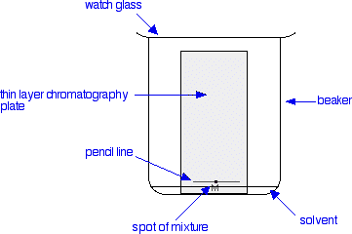To quantify the results, the distance traveled by the substance being considered is divided by the total distance traveled by the mobile phase. (The mobile phase must not be allowed to reach the end of the stationary phase.) This ratio is called the

retardation factor (Rf). In general, a substance whose structure resembles the stationary phase will have low Rf, while one that has a similar structure to the mobile phase will have high retardation factor.

Retardation factors are characteristic, but will change depending on the exact condition of the mobile and stationary phase. For this reason, chemists usually apply a sample of a known compound to the sheet before running the experiment.

Thin-layer chromatography can be used to monitor the progress of a reaction, identify compounds present in a given mixture, and determine the purity of a substance. Specific examples of these applications include: analyzing ceramides and fatty acids, detection of pesticides or insecticides in food and water, analyzing the dye composition of fibers in forensics, as saying the radiochemical purity of radiopharmaceuticals, or identification of medicinal plants and their constituents.

A number of enhancements can be made to the original method to automate the different steps, to increase the resolution achieved with TLC and to allow more accurate quantitative analysis. This method is referred to as HPTLC, or "high-performance TLC". HPTLC typically uses thinner layers of stationary phase and smaller sample volumes, thus reducing the loss of resolution due to diffusion.

# Experimental procedure

* Plate preparation
* Technique
* Separation Process and Principle
* Analysis
* Applications
* Characterization Isolation

# Plate preparation

TLC plates are usually commercially available, with standard particle size ranges to improve reproducibility. They are prepared by mixing the adsorbent, such as silica gel, with a small amount of inert binder like calcium sulfate (gypsum) and water. This mixture is spread as a thick slurry on an unreactive carrier sheet, usually glass, thick aluminum foil, or plastic. The resultant plate is dried and activated by heating in an oven for thirty minutes at 110 °C. The thickness of the absorbent layer is typically around 0.1 – 0.25 mm for analytical

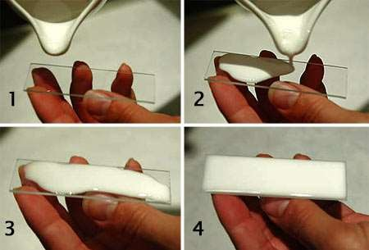purposes and around 0.5 – 2.0 mm for preparative TLC.

# Technique

The process is similar to paper chromatography with the advantage of faster runs, better separations, and the choice between different stationary phases.Because of its simplicity and speed TLC is often used for monitoring chemical reactions and for the qualitative analysis of reaction products. Plates can be labeled before or after the chromatography process using a pencil or other implement that will not interfere or react with the process.

**To run a thin layer chromatography plate, the following procedure is carried out**,

* Using a capillary, a small spot of solution containing the sample is applied to a plate, about 1.5 centimeters from the bottom edge. The solvent is allowed to completely evaporate off to prevent it from interfering with sample's interactions with the mobile phase in the next step. If a non-volatile solvent was used to apply the sample, the plate needs to be dried in a vacuum chamber. This step is often repeated to ensure there is enough analyte at the starting spot on the plate to obtain a visible result. Different samples can be placed in a row of spots the same distance from the bottom edge, each of which will move in its own adjacent lane from its own starting point.
* A small amount of an appropriate solvent (eluent) is poured into a glass beaker or any other suitable transparent container (separation chamber) to a depth of less than 1 centimeter. A strip of filter paper (aka "wick") is put into the chamber so that its bottom touches the solvent and the paper lies on the chamber wall and reaches almost to the top of the container. The container is closed with a cover glass or any other lid and is left for a few minutes to let the solvent vapors ascend the filter paper and saturate the air in the chamber.
* The TLC plate is then placed in the chamber so that the spot(s) of the sample do not touch the surface of the eluent in the chamber, and the lid is closed. The solvent moves up the plate by capillary action, meets the sample mixture and carries it up the plate (elutes the sample). The plate should be removed from the chamber before the solvent front reaches the top of the stationary phase (continuation of the elution will give a misleading result) and dried.
* Without delay, the solvent front, the furthest extent of solvent up the plate, is marked. The plate is visualized. As some plates are pre-coated with a phosphor such as zinc sulfide, allowing many compounds to be visualized by using ultraviolet light; dark spots appear where the compounds block the UV light from striking the plate.

Alternatively, plates can be sprayed or immersed in chemicals after elution. Various visualizing agents react with the spots to produce visible results.

# Separation Process and Principle

Different compounds in the sample mixture travel at different rates due to the differences in their attraction to the stationary phase and because of differences in solubility in the solvent. By changing the solvent, or perhaps using a mixture, the separation of components (measured by the Rf value) can be adjusted. Also, the separation achieved with a TLC plate can be used to estimate the separation of a flash chromatography column. (A compound elutes from a column when the amount of solvent collected is equal to 1/Rf. Chemists often use TLC to develop a protocolfor separation by chromatography and they use TLC to determine which fractions contain the desired compounds. Separation of compounds is based on the as competition of the solute and the mobile phase for binding sites on the stationary phase.

For instance, if normal-phase silica gel is used as the stationary phase, it can be considered polar. Given two compounds that differ in polarity, the more polar compound has a stronger interaction with the silica and is, therefore,better able to displace the mobile phase from the available binding sites. As a consequence, the less polar compound moves higher up the plate (resulting in a higher Rf value). If the mobile phase is changed to a more polar solvent or mixture of solvents, it becomes better at binding to the polar plate and therefore displacing solutes from it, so all compounds on the TLC plate will move higher up the plate. It is commonly said that "strong" solvents (eluents) push the analyzed compounds up the plate, whereas "weak" eluents barely move them. The order of strength/weakness depends on the coating (stationary phase) of the TLC plate.

For silica gel-coated TLC plates, the eluent strength increases in the following order perfluoroalkane (weakest), hexane, pentane, carbon tetrachloride, benzene/toluene, dichloromethane, diethyl ether, ethyl acetate, acetonitrile, acetone, 2-propanol/n-butanol, water, methanol, triethylamine, acetic acid, formic acid (strongest). For C18-coated plates the order is reverse. In other words, when the stationary phase is polar and the mobile phase is non-polar, the method is normal-phase as opposed to reverse-phase. This means that if a mixture of ethyl acetate and hexane as the mobile phase is used, adding more ethyl acetate results in higher Rf values for all compounds on the TLC plate. Changing the polarity of the mobile phase will normally not result in reversed order of running of the compounds on the TLC plate. An eluotropic series can be used as a guide in selecting a mobile phase. If a reversed order of running of the compounds is desired, a polar stationary phase should be used, such C18-

functionalized silica.

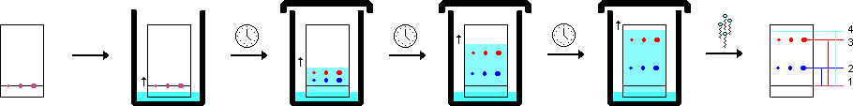

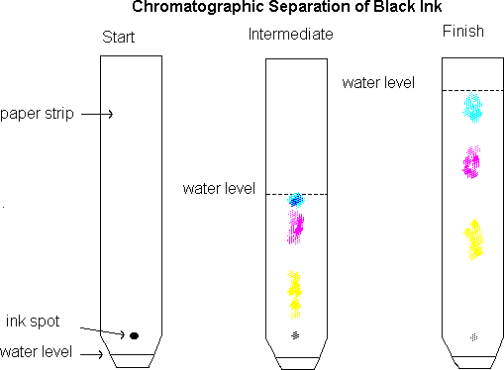

# Analysis

As the chemicals being separated may be colorless, several methods exist to visualize the spots:

* + fluorescent analytes like quinine may be detected under black light (366 nm).
  + Often a small amount of a fluorescent compound, usually manganese-activated zinc silicate, is added to the adsorbent that allows the visualization of spots under UV-C light (254 nm). The adsorbent layer will thus fluoresce light-green by itself, but spots of analytic quench this fluorescence.
  + Iodine vapors are a general unspecific color reagent
  + Specific color reagents into which the TLC plate is dipped or which are sprayed onto the plate exist. Potassium permanganate – oxidation Bromine
  + In the case of lipids, the chromatogram may be transferred to a PVDF membrane and then subjected to further analysis,

Once visible, the *Rf* value, or retardation factor, of each spot can be determined by dividing the distance the product traveled by the distance the solvent front traveled using the initial spotting site as reference. These values depend on the solvent used and the type of TLC plate and are not physical constants.

# Characterization

In organic chemistry, reactions are qualitatively monitored with TLC. Spots sampled with a capillary tube are placed on the plate: a spot of starting material, a spot from the reaction mixture, and a cross-spot with both. A small (3 by 7 cm) TLC plate takes a couple of minutes to run.

The analysis is qualitative, and it will show if the starting material has disappeared, i.e. the reaction is complete, if any product has appeared, and how many products are generated (although this might be underestimated due to co- elution).

It may be visualized using other means as well. This method is much more sensitive than the others and can be used to detect an extremely small amount of a compound, provided that it carries a radioactive atom.

Isolation

Since different compounds will travel a different distance in the stationary phase, chromatography can be used to isolate components of a mixture for further analysis. The separated compounds each occupying a specific area on the plate, they can be scraped off (along with the stationary phase particles) and dissolved into an appropriate solvent. As an example, in the chromatography of an extract of green plant material (for example spinach) shown in 7 stages of development, Carotene elutes quickly and is only visible until step 2.

Chlorophyll A and B are halfway in the final step and lutein the first compound staining yellow. Once the chromatography is over, the carotene can be removed from the plate, extracted into a solvent and placed into a spectrophotometer to determine its spectrum. The quantities extracted are small and a technique such as column chromatography is preferred to separate larger amounts.

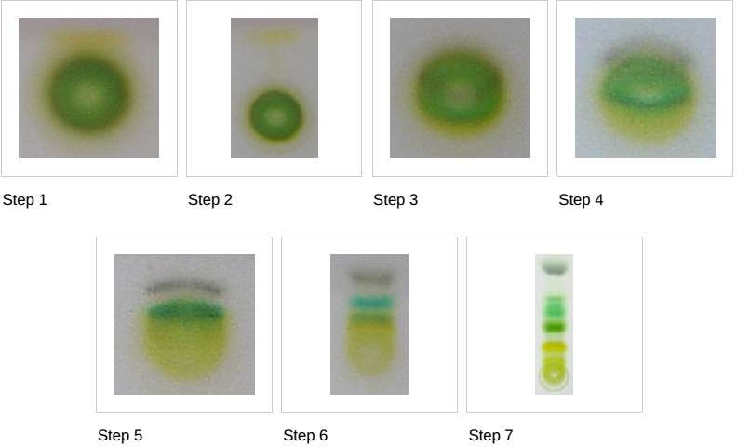

# Advantages of TLC

TLC is very simple to use and inexpensive. Students can be taught this technique and apply its similar principles to other chromatographic techniques. There are little materials needed for TLC (chamber, watch glass, capillary, plate, solvent, pencil, and UV-light). Therefore, once the best solvent is found, it can be applied to other techniques such as [High performance liquid chromatography](https://chem.libretexts.org/Core/Analytical_Chemistry/Instrumental_Analysis/Chromatography/High_performance_liquid_chromatography).

More than 1 compound can be separated on a TLC plate as long as the mobile phase is preferred for each compound. The solvents for the TLC plate can be changed easily and it is possible to use several different solvents depending on your desired results. As stated earlier, TLC can be used to ensure purity of a compound. It is very easy to check the purity using a UV-light. Identification of most compounds can be done simply by checking Rf literature values. You can modify the chromatography conditions easily to increase the optimization for resolution of a specific component.

# Disadvantages of TLC

TLC plates do not have long stationary phases. Therefore, the length of separation is limited compared to other chromatographic techniques. Also, the detection limit is a lot higher. If you would need a lower detection limit, one would have to use other chromatographic techniques. TLC operates as an open system, so factors such as humidity and temperature can be consequences to the results of your chromatogram.

# Common Problems in TLC

There are common problems in TLC that should be avoided. Normally, these problems can be solved or avoided if taught proper techniques.

## Over-large Spots:

Spotting sizes of your sample should be not be larger than 1-2 mm in diameter. The component spots will never be larger than or smaller than your sample origin spot. If you have an over-large spot, this could cause overlapping of other component spots with similar *Rf* values on your TLC plate. If overlapping occurs, it would prove difficult to resolve the different components.

## Uneven Advance of Solvent Front:

Uneven advance of the mobile phase is a common problem encountered in TLC. Consequences would be inaccurate Rf values due to the uneven advance of sample origin spots. This uneven advance can be caused by a few factors listed below.

#### No flat bottom.

When placing the TLC plate into the chamber, place the bottom of the plate on the edge of the chamber (normally glass container (e.g. beaker)) and lean the top of the plate along the other side of the chamber. Also, make sure that the TLC plate is placed in the chamber evenly. Do not tilt the plate or sit it at an angle.

#### Not enough solvent.

There should be enough solvent (depends on size of chamber) to travel up the length of the TLC plate.

#### Plate is not cut evenly.

It is recommended that a ruler is used so that the plate is cut evenly. Rarely, water is used as a solvent because it produces an uneven curve front which is mainly accounted for by its surface tension.

## Streaking:

If the sample spot is too concentrated, the substance will travel up the stationary phase as a streak rather than a single separated spot. In other words, the solvent cannot handle the concentrated sample and in result, moves as much of the substance as it can up the stationary phase. The substance that it cannot move is left behind. This can be eliminated by diluting the sample solution. To ensure that you have enough solution, use a short-wave UV light to see if the spot is visible (normally purple in color), as stated earlier.

# How To Run a TLC Plate

### Step 1: Prepare the developing container

The developing container for TLC can be a pecially designed chamber, a jar with a lid, or a beaker with a watch glass on the top (the latter is used in the undergrad labs at CU). Pour solvent into the chamber to a depth of just less than 0.5 cm. To aid in the saturation of the TLC chamber with solvent vapors, you can line part of the inside of the beaker with filter paper. Cover the beaker with a watch glass, swirl it gently, and allow it to stand while you prepare your TLC plate.

### Step 2: Prepare the TLC plate

TLC plates used in the organic chemistry teaching labs are purchased as 5 cm x 20 cm sheets. Each large sheet is cut horizontally into plates which are 5 cm tall by various widths; the more samples you plan to run on a plate, the wider it needs to be. Shown in the photo to the left is a box of TLC plates, a large uncut TLC sheet, and a small TLC plate which has been cut to a convenient size. Handle the plates are fully so that you do not disturb the coating of adsorbent or get them dirty. Measure 0.5 cm from the bottom of the plate. Using a pencil, draw a line across the plate at the 0.5 cm mark. This is the *origin*: the line on which you will spot the plate.

Take care not to press so hard with the pencil that you disturb the adsorbent. Under the line, mark lightly the name of the samples you will spot on the plate, or mark numbers for time points. Leave enough space between the samples so that they do not run together; about 4 samples on a 5 cm wide plate is advised.

Step 3: Spot the TLC plate

If the sample is not already in solution, dissolve about 1 mg in 1 mL of a volatile solvent such as hexanes, ethyl acetate, or methylene chloride. As a rule of thumb, a concentration of 1% usually works well for TLC analysis. If the sample is too concentrated, it will run as a smear or streak (see troubleshooting section below); if it is not concentrated enough, you will see nothing on the plate. Sometimes you will need to use trial and error to get well-sized, easy to read spots.

Obtain a a microcapillary. In the organic teaching labs, we use 10µL microcaps - they are easier to handle than the smaller ones used in research labs. Dip the microcap into the solution and then **gently** touch the end of it onto the proper location on the TLC plate. Don't allow the spot to become too large - if necessary, you can touch it to the plate, lift it off and blow on the spot. If you repeat these steps, the wet area on the plate will stay small.

This example plate has been spotted with three different quantities of the same solution and is ready to develop. If you are unsure of how much sample to spot, you can always spot multiple quantities and see which looks best.

### Step 4: Develop the plate

Place the prepared TLC plate in the developing beaker, cover the beaker with the watch glass, and leave it undisturbed on your bench top. The solvent will rise up the TLC plate by capillary action. Make sure the solvent does not cover the spot.

Allow the plate to develop until the solvent is about half a centimeter below the top of theplate. Remove the plate from the beaker and immediately mark the solvent front with a pencil. Allow the plate to dry.

### Step 5: Visualize the spots

If there are any colored spots, circle them lightly with a pencil. Most samples are not colored and need to be visualized with a UV lamp. Hold a UV lamp over the plate and circle any spots you see. Beware! UV light is damaging both to your eyes and to your skin! Make sure you are wearing your goggles and do not look directly into the lamp. Protect your skin by wearing gloves.

If the TLC plate runs samples which are too concentrated, the spots will be streaked and/or run together. If this happens, you will have to start over with a more dilute sample to spot and run on a TLC plate.

Here's what overloaded plates look like compared to well-spotted plates. The plate on the left has a large yellow smear; this smear contains the same two compounds which are nicely resolved on the plate next to it.

### TLC Solvents Choice

When you need to determine the best solvent or mixture of solvents (a "solvent system") to develop a TLC plate or chromatography column loaded with an unknown mixture, vary the polarity of the solvent in several trial runs: a process of trial and error.

Carefully observe and record the results of the chromatography in each solvent system. You will find that as you increase the polarity of the solvent system, all the components of the mixture move faster (and vice versa with lowering the polarity). The ideal solvent system is simply the system that gives the best separation. TLC elution patterns usually carry over to column chromatography elution patterns. Since TLC is a much faster procedure than column chromatography, TLC is often used to determine the best solvent system for column chromatography.

For instance, in determining the solvent system for a chromatography procedure, the ideal system is the one that moves the desired component of the mixture to a TLC Rf of 0.25-0.35 and will separate this component from its nearest neighbor by difference in TLC Rf values of at least 0.20.

Because of toxicity, cost, and flammability concerns, the common solvents are hexanes ( and ethyl acetate (an ester). Diethyl ether can be used, but it is very flammable and volatile.

Alcohols (methanol, ethanol) can be used. Acetic acid (a carboxylic acid) can be used, usually as a small percentage component of the system, since it is corrosive, non-volatile, very polar, and has irritating vapors. Acetone (a ketone) can be used. Methylene chloride or and chloroform are good solvents, but are toxic and should be avoided whenever possible.

### Interactions between the Compound and the Adsorbent

The strength with which an organic compound binds to an adsorbent depends on the strength of the following types of interactions: ion-dipole, dipole-dipole, hydrogen bonding, dipole induced dipole, and van der Waals forces. With silica gel, the dominant interactive forces between the adsorbent and the materials to be separated are of the dipole-dipole type.Highly polar molecules interact fairly strongly with the polar Si-OH groups at the surface of these adsorbents, and will tend to stick or adsorb onto the fine particles of the adsorbent while weakly polar molecules are held less tightly. Weakly polar molecules generally tend to move through the adsorbent more rapidly than the polar species. Roughly, the compounds follow the elution order given above.

### The Rf value

The retention factor, or Rf, is defined as the distance traveled by the compound divided by the distance traveled by the solvent. For example, if a compound travels 2.1 cm and the solvent front travels 2.8 cm, the Rf is 0.75: The Rf for a compound is a constant from one experiment to the next only if the chromatography conditions below are also constant:

* + - solvent system
    - adsorbent
    - thickness of the adsorbent
    - amount of material spotted
    - temperature

Since these factors are difficult to keep constant from experiment to experiment, relative Rf values are generally considered. "Relative Rf" means that the values are reported relative to a standard, or it means that you compare the Rf values of compounds run on the same plate at the same time.

The Rf can provide corroborative evidence as to the identity of a compound.

Troubleshooting TLC

All of the above (including the procedure page) might sound like TLC is quite an easy procedure. But what about the first time you run a TLC, and see spots everywhere and blurred, streaked spots? As with any technique, with practice you get better. Examples of common problems encountered in TLC:

### The compound runs as a streak rather than a spot:

The sample was overloaded. Run the TLC again after diluting your sample. Or, your sample might just contain many components, creating many spots which run together and appear as a streak. Perhaps, the experiment did not go as well as expected.

### The sample runs as a smear or a upward crescent**:**

Compounds which possess strongly acidic or basic groups (amines or carboxylic acids) sometimes show up on a TLC plate with this behavior.

Add a few drops of ammonium hydroxide (amines) or acetic acid (carboxylic acids) to the eluting solvent to obtain clearer plates.

### The sample runs as a downward crescent**:**

Likely, the adsorbent was disturbed during the spotting, causing the crescent shape.

### The plate solvent front runs crookedly**:**

Either the adsorbent has flaked off the sides of the plate or the sides of the plate are touching the sides of the container (or the paper used to saturate the container) as the plate develops. Crooked plates make it harder to measure Rf values accurately.

### Many random spots are seen on the plate**:**

Make sure that you do not accidentally drop any organic compound on the plate. If get a TLC plate and leave it laying on your workbench as you do the experiment, you might drop or splash an organic compound on the plate.

### No spots are seen on the plate**:**

You might not have spotted enough compounds, perhaps because the solution of the compound is too dilute. Try concentrating the solution, or spot it several times in one place, allowing the solvent to dry between applications. Some compounds do not show up under UV light; try another method of visualizing the plate (such as staining or exposing to iodine vapor). Or, perhaps you do not have any compound because your experiment did not go as well as planned.

If the solvent level in the developing jar is deeper than the origin (spotting line) of the TLC plate, the solvent will dissolve the compounds into the solvent reservoir instead of allowing them to move up the plate by capillary action. Thus, you will not see spots after the plate is developed. These photos show how the yellow compound is running into the solvent when lifted from the developing jar.

References: