**Gas chromatography**

Gas chromatography is an analytical technique to separate a mixture of vaporizable substances and resolve the mixture into single components.

The gas-liquid chromatography is thus an analytical or preparative separation technique of [chromatography](https://www.internetchemistry.com/chemistry/chromatography.htm) that is based on the principles of partition chromatography and adsorption chromatography. After the chromatographic separation by the gas chromatograph, the individual substances are identified by different detector systems - such as by mass spectrometry.

Gas chromatography differs from other forms of chromatography in that the mobile phase is a gas and the components are separated as vapors. It is thus used to separate and detect small molecular weight compounds in the gas phase. The sample is either a gas or a liquid that is vaporized in the injection port. The mobile phase for gas chromatography is a carrier gas, typically helium because of its low molecular weight and being chemically inert. The pressure is applied and the mobile phase moves the analyte through the column. The separation is accomplished using a column coated with a stationary phase.

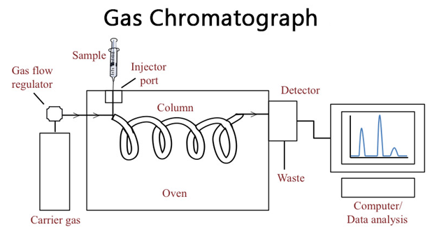

**Principle of Gas chromatography**

The equilibrium for gas chromatography is partitioning, and the components of the sample will partition (i.e. distribute) between the two phases: the stationary phase and the mobile phase.

Compounds that have a greater affinity for the stationary phase spend more time in the column and thus elute later and have a longer **retention time (Rt)** than samples that have a higher affinity for the mobile phase.

Affinity for the stationary phase is driven mainly by intermolecular interactions and the polarity of the stationary phase can be chosen to maximize interactions and thus the separation.

Ideal peaks are Gaussian distributions and symmetrical, because of the random nature of the analyte interactions with the column.

* The separation is hence accomplished by partitioning the sample between the gas and a thin layer of a nonvolatile liquid held on a solid support.
* A sample containing the solutes is injected into a heated block where it is immediately vaporized and swept as a plug of vapor by the carrier gas stream into the column inlet.
* The solutes are adsorbed by the stationary phase and then desorbed by a fresh carrier gas.
* The process is repeated in each plate as the sample is moved toward the outlet.
* Each solute will travel at its own rate through the column.
* Their bands will separate into distinct zones depending on the partition coefficients, and band spreading and enters into the detector.
* Here they register a series of signals resulting from concentration changes and rates of elution on the recorder as a plot of time versus the composition of carrier gas stream.
* The appearance time, height, width, and area of these peaks can be measured to yield quantitative data.

**Gas chromatograph is mainly composed of the following parts:**

1. **Carrier gas in a high-pressure cylinder with attendant pressure regulators and flow meters**
2. Helium, N2, H, Argon are used as carrier gases.
3. Helium is preferred for thermal conductivity detectors because of its high thermal conductivity relative to that of most organic vapors.
4. N2 is preferable when a large consumption of carrier gas is employed.
5. Carrier gas from the tank passes through a toggle valve, a flow meter, (1-1000 ml/min), capillary restrictors, and a pressure gauge (1-4 atm).
6. Flow rate is adjusted by means of a needle valve mounted on the base of the flow meter and controlled by capillary restrictors.
7. The operating efficiency of the gas chromatograph is directly dependent on the maintenance of constant gas flow.
8. **Sample injection system**

**There are two system of injecting samples into the gas chromatography**

* 1. **Manual Injection system**
  2. **Automatic injection system**
* Liquid samples are injected by a micro syringe with a needle inserted through a septum into a heated metal block by a resistance heater.
* Gaseous samples are injected by a gas-tight syringe or through a by-pass loop and valves.
* Typical sample volumes range from 0.1 to 0.2 ml.

1. **The separation column**

* The heart of the gas chromatography is the column which is made of metals bent in U shape or coiled into an open spiral or a flat pancake shape.
* Copper is useful up to 2500
* Swege lock fittings make column insertion easy.
* Several sizes of columns are used depending upon the requirements.

1. **Detector**

* Detectors sense the arrival of the separated components and provide a signal.
* These are either concentration-dependent or mass dependant.
* The detector should be close to the column exit and the correct temperature to prevent decomposition. The commonly used detector are
  1. FID detector
  2. ECD detector
  3. TCD detector etc

**ECD: Electron Capture Detector**

The electron capture detector (ECD) is a selective detector for electro-negative compounds, especially halogens.  A (beta-ray) radio-active source which can ionize the carrier gas is located in the detector. A current is produced between two electrodes in the detector supplied with a potential difference and this is monitored as a continuous background current. When there are electro-negative components present in the carrier gas, the background current is reduced because these components capture electrons.

The mechanism of operation of the ECD is slightly more complex. The electrons emitted by the radioactive foil move too fast to be captured by the analyte molecules. They have to be slowed down. This can be achieved by introducing an inert gas into the ECD cell that collides with the rapid electrons and in that way slowing them down.

For this reason some percentage of methane (5%) is added to the make-up gas argon (the most sensitive gas for an ECD regarding its ionizing capability). Methane reduces the electron energy by collision without ionizing the methane and avoids interference effects such as component ionization.

If helium is preferred as carrier gas for the column, simply using a make-up gas such as nitrogen or argon/methane will generate the expected detector sensitivity. In this particular case the function of the make-up gas is not to provide more gas but to improve the detector ionisation yield. In other words: make-up gas does not play a role in the chromatographic process in the column. It is only added the moment the carrier gas leaves the column. In this way the separaion can be performed under optimum carrier gas conditions while simultaneously the detector will generate an optimum signal-to-noise ratio.

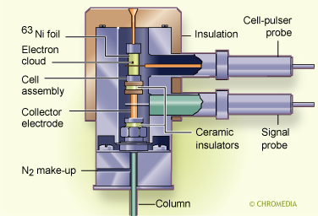

**Thermal conductivity detector (TCD)**

**A universal detector and can detect air, hydrogen, carbon monoxide, nitrogen, sulfur oxide, inorganic gases and many other compounds**

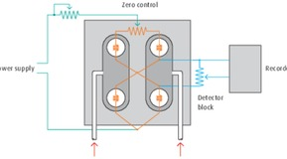

Thermal conductivity (TCD) is a commonly used detector in gas chromatography.  TCD works by having two parallel tubes both containing gas and heating coils. The gases are examined by comparing the heat loss rate from the heating coils into the gas. Normally one tube holds a reference gas and the sample to be tested is passed through the other.  Using this principle, a TCD senses the changes in the thermal conductivity of the column effluent and compares it to a reference flow of carrier gas. Most compounds have a thermal conductivity much less than that of the common carrier gases of hydrogen or helium. Therefore, when an analyte elutes from the column, the thermal conductivity of the effluent is reduced and a detectable signal is produced. Helium has traditionally been the favoured carrier gas but as laboratory trends change, Linde is also able to offer hydrogen as an alternative to helium as a carrier gas for GC-TCD applications.

While flame ionization detector (FID) can provide very good resolution, TCD is a good general purpose detector for initial investigations with an unknown sample, as it responds to all compounds, thanks to the fact that all compounds, organic and inorganic, have a different thermal conductivity from helium. The TCD is also used in the analysis of permanent and inorganic gases (for example argon, oxygen, nitrogen, carbon dioxide, carbon monoxide, sulfur dioxide) because it responds to all these substances unlike the FID, which cannot detect compounds which do not contain carbon-hydrogen bonds.

1. **Recorder**

* The recorder should be generally 10 mv (full scale) fitted with a fast response pen (1 sec or less). The recorder should be connected with a series of good quality resistances connected across the input to attenuate the large signals.
* An integrator may be a good addition.

**The procedure of analysis**

**Step 1: Sample Injection and Vaporization**

1. A small amount of liquid sample to be analyzed is drawn up into a syringe.
2. The syringe needle is positioned in the hot injection port of the gas chromatograph and the sample is injected quickly.
3. The injection of the sample is considered to be a “point” in time, that is, it is assumed that the entire sample enters the gas chromatograph at the same time, so the sample must be injected quickly.
4. The temperature is set to be higher than the boiling points of the components of the mixture so that the components will vaporize.
5. The vaporized components then mix with the inert gas mobile phase to be carried to the gas chromatography column to be separated.

**Step 2: Separation in the Column**

* Components in the mixture are separated based on their abilities to adsorb on or bind to, the stationary phase.
* A component that adsorbs most strongly to the stationary phase will spend the most time in the column (will be retained in the column for the longest time) and will, therefore, have the longest retention time (Rt). It will emerge from the gas chromatograph last.
* A component that adsorbs the least strongly to the stationary phase will spend the least time in the column (will be retained in the column for the shortest time) and will, therefore, have the shortest retention time (Rt).  It will emerge from the gas chromatograph first.
* If we consider a 2 component mixture in which component A is more polar than component B then:

1. component A will have a **longer retention time** in a polar column than component B
2. component A will have a **shorter retention time** in a non-polar column than component B.

**Step 3: Detecting and Recording Results**

1. The components of the mixture reach the detector at different times due to differences in the time they are retained in the column.
2. The component that is retained the shortest time in the column is detected first. The component that is retained the longest time in the column is detected last.
3. The detector sends a signal to the chart recorder which results in a peak on the chart paper. The component that is detected first is recorded first.  The component that is detected last is recorded last.

**Advantages**

* The use of longer columns and higher velocity of carrier gas permits the fast separation in a matter of a few minutes.
* Higher working temperatures up to 5000C and the possibility of converting any material into a volatile component make gas chromatography one of the most versatile techniques.
* GC is popular for environmental monitoring and industrial applications because it is very reliable and can be run nearly continuously.
* GC is typically used in applications where small, volatile molecules are detected and with non-aqueous solutions.
* GC is favored for non-polar molecules.

**Disadvantages and Limitations**

1. Compound to be analyzed should be stable under GC operation conditions.
2. They should have a vapor pressure significantly greater than zero.
3. Typically, the compounds analyzed are less than 1,000 Da, because it is difficult to vaporize larger compounds.
4. The samples are also required to be salt-free; they should not contain ions.
5. Very minute amounts of a substance can be measured, but it is often required that the sample must be measured in comparison to a sample containing the pure, suspected substance known as a reference standard.

**Applications**

* GC analysis is used to calculate the content of a chemical product, for example in assuring the quality of products in the chemical industry; or measuring toxic substances in soil, air or water.
* Gas chromatography is used in the analysis of:

(a) air-borne pollutants   
(b) performance-enhancing drugs in athlete’s urine samples   
(c) oil spills   
(d) essential oils in perfume preparation

* GC is very accurate if used properly and can measure picomoles of a substance in a 1 ml liquid sample, or parts-per-billion concentrations in gaseous samples.
* Gas Chromatography is used extensively in forensic science. Disciplines as diverse as solid drug dose (pre-consumption form) identification and quantification, arson investigation, paint chip analysis, and toxicology cases, employ GC to identify and quantify various biological specimens and crime-scene evidence.