***INTRODUCTION TO GLOBAL LEGAL SYSTEM***

1. *Introduction to Law*
2. *World Wide growth of legal system*
3. *Evolution of Law*
4. *Why need of legal system was felt*
5. *Meaning of Law*
6. *Definition of Law*
7. *Different types of Law*
8. *Sources of Law*
9. *Primary source of Muhammadan Law*
10. ***INTRODUCTION TO LAW:***

*There are hundred of types of legal system world wide but the international law is of great importance created by practice of sovereign states by agreement or treaties. Despite this variety of law there is division between religious legal system at secular legal system both holds quite different views as to law as to source or scope sanction and function. The source of religious law is deite, legislating through the profits and religion on the other hand the secular law is how ever a man made law in which office of the judge is separate and is often enforced by guaranty of judicial independent while in religious legal system disputes are usually adjudicated by an officer of the religion or the same person as judge and praised. Now days there are few countries whose legal system is exclusively religious however a large number of countries having secular system . The feature of secular system may be built in such kind of legal system like French and Russian constitution or the very first words of the first amendment to the American constitution “ congress shall make no law respecting an establishment of religion”. A number of other countries have dual system in such type of legal system the legal matters are govern by both religious and secular system, religious courts adjudicate on the matters such as marriage, divorce, family relationship. However, a secular system with this kind of state courts cover the wider field of public and commercial law. This was the position in England until the 1850. And is the case in today in Israel, India and Pakistan. In these dual jurisdiction human activities govern by one or other system which may depend on the stage of economic and political development of country in question.*

1. ***WORLD WIDE GROWTH OF LEGAL SYSTEM:***

*The diversity of laws of in the modern world is a fact in era of globalization. Each political societies having their own legal system in the world and the several laws are co-existing within a legal system. The diversity of law poses problems since the laws of the world are expressed in different languages and forms since they evolved in societies. Every legal system of the world is interconnected with each other specially in cases of human rights, justice and peace, trade good governs, accountability of institutions and democracy in state due to these reasons every state has to face the challenges in order to improve their own legal system. Globalization is a process of interaction among the states, people, companies and governments of different nations a process driven by international trade and investment and added by information technology. This process affect the environment, culture, economic development and prosperity, political and legal system and human physical well-being in societies around the world. In simple word globalization is a phenomenon that practically extend the communication bridge among states, its relationship to house hold law and made strategies and requirements. Presently working for lawful frameworks of the world by different financial and legitimate parameters. In the Pakistani point of view the legitimate framework must be produced in all encompassing way and it hot not damage our theory of Islam.*

1. ***EVOLUTION OF LAW:***

*Historically, socially emergent ideas of legal principles with the nature of reality occurred prior to their adoption by political authorities voluntary forms of governance through customary private laws, pre-existed laws and effectively ordered human affairs . Law arose as a spontaneous order. Something to be discovered rather than enacted. Law is an evolutionary systemic process involving the experience of vast number of people.*

1. ***WHY NEED OF LEGAL SYSTEM WAS FELT:***
2. *Protect society interest*
3. *Deter criminal behavior*
4. *Enforce norms, ethics and morals*
5. *Uphold individual rights*
6. *Support those in power*
7. *To punish the law breakers or wrong doers*
8. ***MEANING OF LAW:***

*The term law is derived from the German word LAG it means fixed or evenly.*

1. ***DEFINITION OF LAW:***

*Definition of law according to Solmond. Law is the body of principal recognized and applied by the state in the administration of justice.*

*Definition of law according to Austin. Law is the command of sovereign. It imposes a duty and is backed by sanction.*

1. ***DIFFERENT TYPES OF LAW:***

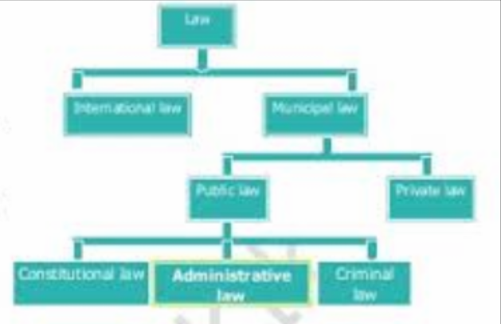

1. ***SOURCES OF LAW:***

*Legal sources of law*

*Legislation Custom Precedents Agreements/ Conventions*

1. ***PRIMARY SOURCE OF MUHAMMADAN LAW:***
2. *Quran*
3. *Sunnat and Ahadis*
4. *Ijma*
5. *Qiyas*