**Meaning of planning**

Planning is the first as well as the most crucial function of management and is considered as a foundation to all other functions of management. In simple sense, it is an act or process of making plans such as – objectives, policies, procedures and strategies.

As stated above that, planning is the fundamental function of management, which involves deciding beforehand, what is to be done, when is it to be done, how it is to be done and who is going to do it. It is an intellectual process which lays down an organization’s objectives and develops various courses of action, by which the organisation can achieve those objectives. It chalks out exactly, how to attain a specific goal.

Planning is nothing but thinking before the action takes place. It helps us to take a peep into the future and decide in advance the way to deal with the situations, which we are going to encounter in future. It involves logical thinking and rational decision making.

Moreover, planning is looking ahead and chalking out future course of action to be followed. It is a preparatory step. It is a systematic activity which determines when, how and who is going to perform a specific job. Planning is a detailed programme regarding future courses of action. It is rightly said ―Well plan is half done

**Definitions of planning**

Being the starting point in managerial functions, broadly speaking, planning is concerned with determining various courses of action in the light of organisational objectives and premises and then selecting the best possible alternative.

The domain researchers like Koontz and O’Donnell that “Planning is deciding in advance what to do, when to do, how to do and who is to do it. It is bridging the gap from where we are to where we want to go.”

While, Alford and Beatt explained the term that “Planning is the thinking process, the organised foresight, the vision based on fact and experience that is required for intelligent action.”

In the same vein, scholars Louis A. Allen said that “Management planning involves the development of forecasts, objectives, policies, programmes, procedures, schedules and budgets.”

Tlieo Haimann says about the planning that “Planning is deciding in advance what is to be done. When a manager plans, he projects a course of action, for the future, attempting to achieve a consistent, coordinated structure of operations aimed at the desired results.”

Accordind to Urwick “Planning is a mental predisposition to do things in orderly way, to think before acting and to act in the light of facts rather than guesses.”

In last, Weihrich and Koontz – “Planning is an intellectually demanding process; it requires that we consciously determine courses of action and base our decisions on purpose, knowledge and considered estimates.”

**DECENTRALIZED PLANNING**

Soon after Independence, we adopted economic planning to achieve quick economic development. We had hoped that such planned development would remove poverty in a short time and bring prosperity to every nook and corner of the country. We have, however, been disappointed as poverty still exists on a large scale and the inequalities in the levels of income between the rich and the poor continue to expand.

In these plans the policies and programmes are formulated centrally at the top. The Planning

Commission is the highest policy-making body in this set-up. These plans are implemented at the lower levels like the state, district, tehsil, union council etc.

However, such central planning could not fulfill many local needs, and local resources also could not be mobilized for use in the implementation of the plans as all funds were allocated centrally. Many local environmental concerns were also neglected in the formulation and implementation of the plans.

To remove these deficiencies of central planning, efforts are being made to involve people at the local level in the formulation and implementation of plans. Such planning is known as decentralized planning.

**Definition of Centralized Planning**

Decentralization, interpreted in simple terms, would mean moving away from the center or deconcentration. In the context of development, which is our concern here, decentralization means transfer of certain authority and power in the matter of formulation and implementation of development plans from the highest organization or institution at the national level or state level to organisations or institutions at the sub-state level.

The lower level, which includes district, Tehsil and Union Councils will have a particular role in the planning exercise and will be vested with the powers and the responsibilities associated with the role. In a truly decentralized situation such power will include the power to determine goals and targets and to raise resources locally.

Decentralized Planning can, thus, be defined as a type of planning where local organisations and institutions formulate, adopt, execute actions and supervise the plan without interference by the central body.

Decentralized Planning depends to a great deal on the devolution of functions and powers from government at the top to the local levels.

**Nature of Planning**

* Planning is goal-oriented.
* Planning is looking ahead.
* Planning is an intellectual process.
* Planning involves choice & decision making.
* Planning is the primary function of management / Primacy of Planning.
* Planning is a Continuous Process.
* Planning is all Pervasive.
* Planning is designed for efficiency.
* Planning is Flexible.

**Purpose of Planning: -**

* Planning Provides Direction
* Planning Provides opportunity to analyze alternative courses of action
* Planning Reduces uncertainties
* Planning Minimizes impulsive and arbitrary decisions
* Planning makes King-pin function
* Planning needs for efficient use of resources.
* Planning needs for adaptive responses
* Planning needs for Anticipative action

**Characteristics of Planning**

[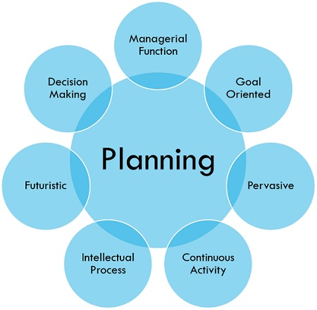](https://businessjargons.com/wp-content/uploads/2016/12/characteristics-of-planning.jpg)

1. **Managerial function:**

Planning is a first and foremost managerial function provides the base for other functions of the management, i.e. organizing, staffing, directing and controlling, as they are performed within the periphery of the plans made.

1. **Goal oriented:**

It focuses on defining the goals of the organisation, identifying alternative courses of action and deciding the appropriate action plan, which is to be undertaken for reaching the goals.

1. **Pervasive:**

It is pervasive in the sense that it is present in all the segments and is required at all the levels of the organisation. Although the scope of planning varies at different levels and departments.

1. **Continuous Process:**

Plans are made for a specific term, say for a month, quarter, and year and so on. Once that period is over, new plans are drawn, considering the organization’s present and future requirements and conditions. Therefore, it is an ongoing process, as the plans are framed, executed and followed by another plan.

1. **Intellectual Process:**

It is a mental exercise at it involves the application of mind, to think, forecast, imagine intelligently and innovate etc.

1. **Futuristic:**

In the process of planning we take a sneak peek of the future. It encompasses looking into the future, to analyze and predict it so that the organisation can face future challenges effectively.

1. **Decision making:**

Decisions are made regarding the choice of alternative courses of action that can be undertaken to reach the goal. The alternative chosen should be best among all, with the least number of the negative and highest number of positive outcomes.

Planning is concerned with setting objectives, targets, and formulating plans to accomplish them. The activity helps managers analyze the present condition to identify the ways of attaining the desired position in future. It is both, the need of the organisation and the responsibility of managers.

**Importance of Planning**

It helps managers to improve future performance, by establishing objectives and selecting a course of action, for the benefit of the organisation.

It minimizes risk and uncertainty, by looking ahead into the future.

It facilitates the coordination of activities. Thus, reduces overlapping among activities and eliminates unproductive work.

It states in advance, what should be done in future, so it provides direction for action.

It uncovers and identifies future opportunities and threats.

It sets out standards for controlling. It compares actual performance with the standard performance and efforts are made to correct the same.

Planning is present in all types of organisations, households, sectors, economies, etc. We need to plan because the future is highly uncertain and no one can predict the future with 100% accuracy, as the conditions can change anytime. Hence, planning is the basic requirement of any organization for the survival, growth and success.

**Steps of Planning**

Planning is an intellectual process which an executive carries out before he does any job with the help of other people. It involves the following steps:

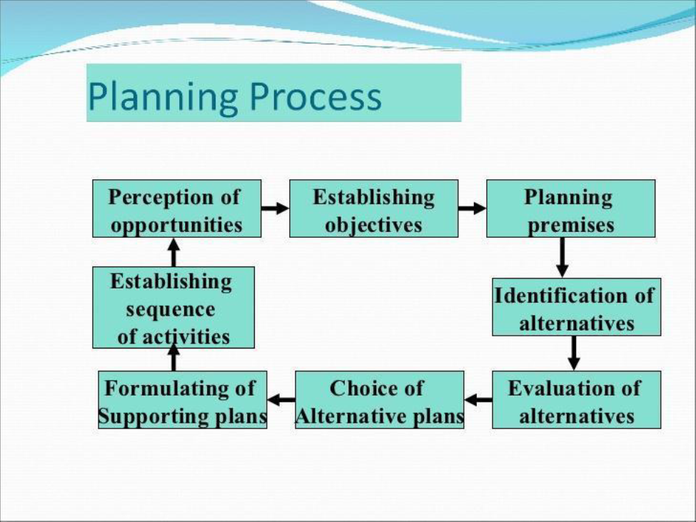

By planning process, an organisation not only gets the insights of the future, but it also helps the organisation to shape its future. Effective planning involves simplicity of the plan, i.e. the plan should be clearly stated and easy to understand because if the plan is too much complicated it will create chaos among the members of the organisation. Further, the plan should fulfill all the requirements of the organisation.

* **Establishing objectives**

The first step in planning is to identify certain objectives.

The objectives set must clearly indicate what is to be achieved, where action should take place, who should perform it and when it is to be accomplished.

The objectives should be established for the entire organization and for each and every department.

Planning has no utility if it is not related to certain objectives.

* **Development of planning premises**

Planning premises are the assumptions and predictions about the future.

The assumptions are the basis of planning. Forecasting is important in premising. It helps in making realistic assumptions about sales, costs, prices, products etc. in future.

This requires a collection of data on present trends and future possibilities. Identification of alternative course of action.

Usually, there are several alternatives for any plan. The manager should try to find out all the possible alternatives.

At the time of developing alternatives he should screen out most viable alternatives. So he has to analyze in detail a limited number of alternatives.

* **Evaluation of alternatives**

The various alternatives identified are evaluated and compared in terms of their expected costs and benefits.

Many quantitative techniques are available to evaluate alternatives.

After identifying the various alternatives the best alternative should be selected for implementation.

* **Choice of alternatives**

The next step is to develop detailed alternative plans for its implementation.

Derivative plans are required to support the overall plans.

The derivative plans are developed in the frame work of overall plans.

These are drawn up with respect to different areas of activity.

* **Formulating the supporting plan**

It is very important to get the cooperation of the subordinates at every stage of its implementation.

For this purpose the plans should be communicated and explained to them so that they can get the clear picture of what to be done.

An organization is not benefited from planning process until they are put into action.

* **Establishing sequence of activities**

Sufficient information must be collected in order to make plans and sub plans subsequently.

Necessary information includes the critical assessment of current status of the organization together with a forward look at the environment that is anticipated.

The collection and forecasting of the information must be done in terms of external and internal environment.

The considerations of the external environments know the competitions now and in the future.

The assessment of internal environment may consist of the strong and weak point of the organization.

* **Perception of opportunities**

To ensure the plans are proceeding along the right lines, the actual performance is compared with the planned performance.

In this way, any short coming can be noted and suitable remedial action can be taken.