Congress of Vienna

[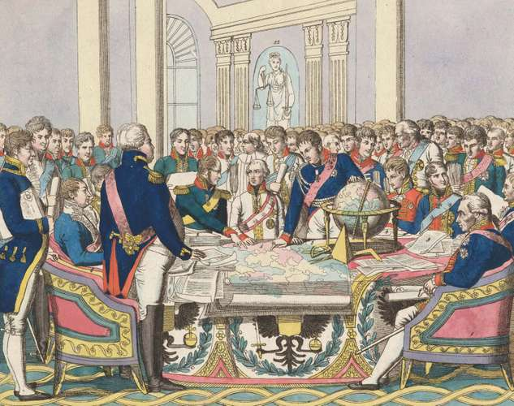](https://cdn.britannica.com/29/175629-050-4C218DBE/Congress-of-Vienna-watercolour-etching-collection-Friedrich.jpg)Congress of Vienna, assembly in 1814–15 that reorganized [Europe](https://www.britannica.com/topic/history-of-Europe/The-age-of-revolution#ref58407) after the [Napoleonic Wars](https://www.britannica.com/event/Napoleonic-Wars). It began in September 1814, five months after [Napoleon I](https://www.britannica.com/biography/Napoleon-I)’s first abdication and completed its “Final Act” in June 1815, shortly before the [Waterloo](https://www.britannica.com/event/Battle-of-Waterloo) campaign and the final defeat of Napoleon. The settlement was the most-comprehensive treaty that Europe had ever seen.

Congress of Vienna*The Congress of Vienna*,

Preliminaries

[Austria](https://www.britannica.com/place/Austria), [Prussia](https://www.britannica.com/place/Prussia), [Russia](https://www.britannica.com/place/Russia), and [Great Britain](https://www.britannica.com/place/United-Kingdom), the four powers that were chiefly instrumental in the overthrow of Napoleon, had concluded a special alliance among themselves with the [Treaty of Chaumont](https://www.britannica.com/event/Treaty-of-Chaumont), on March 9, 1814, a month before Napoleon’s first abdication. The subsequent treaties of peace with [France](https://www.britannica.com/place/France), signed on May 30 not only by the “four” but also by [Sweden](https://www.britannica.com/place/Sweden) and [Portugal](https://www.britannica.com/place/Portugal) and on July 20 by [Spain](https://www.britannica.com/place/Spain), [stipulated](https://www.merriam-webster.com/dictionary/stipulated) that all former [belligerents](https://www.merriam-webster.com/dictionary/belligerents) should send plenipotentiaries to a congress in [Vienna](https://www.britannica.com/place/Vienna). Nevertheless, the “four” still intended to reserve the real [decision making](https://www.britannica.com/topic/decision-making) for themselves.

Delegates

[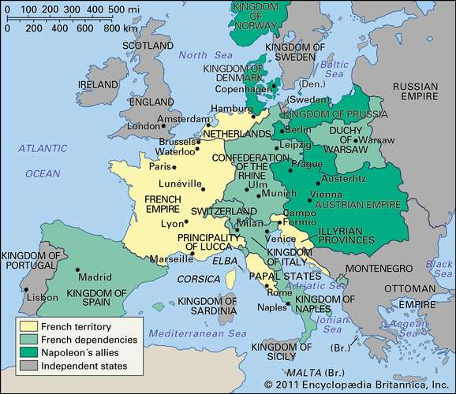](https://cdn.britannica.com/98/698-050-6345D610/Europe-1812.jpg)Representatives began to arrive in Vienna toward the end of September 1814. All of Europe sent its most-important statesmen. [Klemens, prince von Metternich](https://www.britannica.com/biography/Klemens-von-Metternich), principal minister of Austria, represented his emperor, [Francis II](https://www.britannica.com/biography/Francis-II-Holy-Roman-emperor). Tsar [Alexander I](https://www.britannica.com/biography/Alexander-I-emperor-of-Russia) of Russia directed his own diplomacy. King [Frederick William III](https://www.britannica.com/biography/Frederick-William-III) of Prussia had [Karl, prince von Hardenberg](https://www.britannica.com/biography/Karl-August-von-Hardenberg), as his principal minister. Great [Britain](https://www.britannica.com/place/United-Kingdom) was represented by its foreign minister, [Viscount](https://www.britannica.com/biography/Robert-Stewart-Viscount-Castlereagh-2nd-marquess-of-Londonderry)

[Castlereagh](https://www.britannica.com/biography/Robert-Stewart-Viscount-Castlereagh-2nd-marquess-of-Londonderry).

Europe: 1812

When Castlereagh had to return to his parliamentary duties, the [duke of Wellington](https://www.britannica.com/biography/Arthur-Wellesley-1st-Duke-of-Wellington) replaced him, and Lord Clancarty was principal representative after the duke’s departure. The restored [Louis XVIII](https://www.britannica.com/biography/Louis-XVIII) of France sent [Charles-Maurice de Talleyrand](https://www.britannica.com/biography/Charles-Maurice-de-Talleyrand-prince-de-Benevent). Spain, Portugal, and Sweden had only men of moderate ability to represent them. Many of the rulers of the minor states of Europe put in an appearance. With them came a host of courtiers, secretaries, and ladies to enjoy the magnificent social life of the Austrian court.

Assisting Metternich as host, [Friedrich Gentz](https://www.britannica.com/biography/Friedrich-Gentz) played a vital role in the management of [protocol](https://www.merriam-webster.com/dictionary/protocol) and in the secretarial organization of the congress. The social side of the congress was, in fact, one of the causes of the long and unexpected delay in producing a result, for Metternich at least sometimes subordinated business to pleasure.

Procedure

The procedure of the congress was determined by the difficulty and complexity of the issues to be solved. First there was the problem of the organization of the congress, for which there was no precedent. The “four” were determined to keep the management of the main problems entirely in their own hands, but since they had rather rashly summoned a congress, they had to pay some attention to it. Thus, the ministers of Austria, Prussia, Russia, and Great Britain assembled early for discussions and finally agreed, on September 22, 1814, that the “four” should be those to decide the future of all the conquered territories. They were then to communicate their decisions to France and Spain. The full congress was to be summoned only when all was ready.

Such was the situation that Talleyrand found when he arrived on September 24. He refused to accept it and was supported by Spain’s representative, the marqués de Labrador. Talleyrand denied that either the “four” or the “six” (including France and Spain) was a legally [constituted](https://www.merriam-webster.com/dictionary/constituted) body and desired that the congress should be summoned to elect a directing committee. If any other body had rights in the matter, it was the group of powers—Austria, Great Britain, Prussia, Russia, Sweden, Spain, and Portugal—that had signed the 1814 [Treaty of Paris](https://www.britannica.com/event/Treaties-of-Paris-1814-1815) with France (thus, the “eight”), which ended the Napoleonic Wars for the first time. The core four were much disturbed, knowing that the smaller powers would support Talleyrand if they gave him the chance of appealing to them. They had no intention of giving way, however, and refused to summon a meeting of all the representatives. The opening of the congress was postponed until November 1. No solution could be found, however, and after a meeting of the “eight” on October 30, the opening was again postponed.

Meanwhile, work proceeded without the sanction of the main body of plenipotentiaries. The “four” discussed the main territorial problems informally among themselves. The “eight” assumed the formal direction of the congress; a committee of German states met to draw up a constitution for [Germany](https://www.britannica.com/place/Germany/Results-of-the-Congress-of-Vienna#ref58180), and a special committee on [Switzerland](https://www.britannica.com/place/Switzerland) was appointed by the “four.” Talleyrand was thus excluded from the main work of the congress, but his protests on behalf of the smaller powers grew fainter as he realized that the “four” were not in agreement; Castlereagh and Metternich gradually won his confidence and at last insisted on [Bourbon](https://www.britannica.com/topic/house-of-Bourbon#ref59286) France’s being admitted to the core group. It was that committee of five that was the real Congress of Vienna. Between January 7 and February 13, 1815, it settled the frontiers of all territories north of the [Alps](https://www.britannica.com/place/Alps) and laid the foundations for the settlement of [Italy](https://www.britannica.com/place/Italy). Meanwhile, the committee of eight dealt with more-general matters. The congress as a representative body of all Europe never met.

Decisions of The Congress

[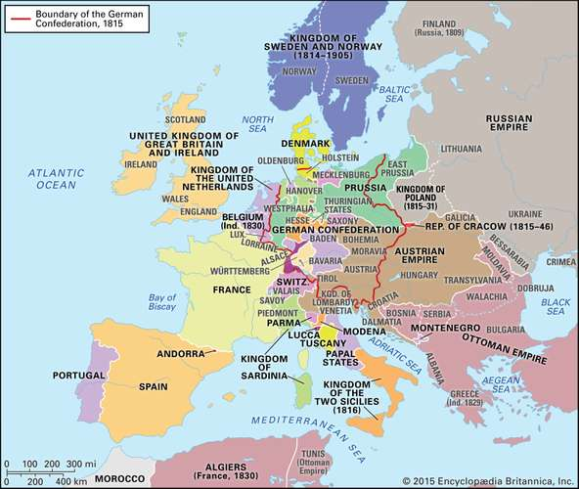](https://cdn.britannica.com/62/181962-050-1961C0AA/Europe-Congress-of-Vienna.jpg)The major points of friction occurred over the [disposition](https://www.merriam-webster.com/dictionary/disposition) of [Poland](https://www.britannica.com/place/Poland) and [Saxony](https://www.britannica.com/place/Saxony-historical-region-duchy-and-kingdom-Europe), the conflicting claims of [Sweden](https://www.britannica.com/place/Sweden), [Denmark](https://www.britannica.com/place/Denmark), and [Russia](https://www.britannica.com/place/Russia), and the adjustment of the borders of the German states. In general, Russia and [Prussia](https://www.britannica.com/place/Prussia) were opposed by [Austria](https://www.britannica.com/place/Austria), [France](https://www.britannica.com/place/France), and England, which at one point (January 3, 1815) went so far as to conclude a secret treaty of defensive alliance. The major final agreements were as follows.

Europe after the Congress of Vienna (1815

In return for acquiring [Poland](https://www.britannica.com/topic/history-of-Poland), Alexander gave back [Galicia](https://www.britannica.com/place/Galicia-historical-region-Eastern-Europe) to Austria and gave Thorn and a region around it to Prussia; [Kraków](https://www.britannica.com/place/Krakow) was made a free town. The rest of the [Duchy of Warsaw](https://www.britannica.com/place/Duchy-of-Warsaw) was incorporated as a separate kingdom under the Russian emperor’s [sovereignty](https://www.merriam-webster.com/dictionary/sovereignty). Prussia got two-fifths of Saxony and was compensated by extensive additions in [Westphalia](https://www.britannica.com/place/Westphalia) and on the left bank of the [Rhine River](https://www.britannica.com/place/Rhine-River). It was Castlereagh who insisted on Prussian acceptance of the latter territory, with which it had been suggested the king of Saxony should be compensated. Castlereagh wanted Prussia to guard the territories of the Rhine region against France and act as a buttress to the new [Kingdom of the Netherlands](https://www.britannica.com/place/Netherlands), which [comprised](https://www.merriam-webster.com/dictionary/comprised) both the former [United Provinces](https://www.britannica.com/place/Dutch-Republic) and [Belgium](https://www.britannica.com/place/Belgium). Austria was compensated by [Lombardy](https://www.britannica.com/place/Lombardy) and [Venice](https://www.britannica.com/place/Venice) and got back most of [Tirol](https://www.britannica.com/place/Tirol-state-Austria). [Bavaria](https://www.britannica.com/place/Bavaria), [Württemberg](https://www.britannica.com/place/Wurttemberg), and [Baden](https://www.britannica.com/place/Baden-historical-state-Germany) on the whole did well. [Hanover](https://www.britannica.com/place/Hanover-historical-state-Germany) was also enlarged. The outline of a constitution, a loose confederation, was drawn up for [Germany](https://www.britannica.com/topic/history-of-Germany)—a triumph for Metternich. Denmark lost [Norway](https://www.britannica.com/place/Norway) to Sweden but got [Lauenburg](https://www.britannica.com/place/Lauenburg-former-duchy-Germany), while Swedish [Pomerania](https://www.britannica.com/place/Pomerania) went to Prussia. [Switzerland](https://www.britannica.com/place/Switzerland) was given a new constitution.

In [Italy](https://www.britannica.com/topic/history-of-Italy), [Piedmont](https://www.britannica.com/place/Piedmont-region-Italy) absorbed [Genoa](https://www.britannica.com/place/Genoa-Italy); [Tuscany](https://www.britannica.com/place/Tuscany) and [Modena](https://www.britannica.com/place/Modena-Italy) went to an Austrian archduke; and the [Duchy of Parma and Piacenza](https://www.britannica.com/place/Duchy-of-Parma-and-Piacenza) was given to [Marie-Louise](https://www.britannica.com/biography/Marie-Louise-Austrian-archduchess), consort of the deposed Napoleon. The [Papal States](https://www.britannica.com/place/Papal-States) were restored to the pope, and Naples went to the Sicilian [Bourbons](https://www.britannica.com/topic/house-of-Bourbon#ref59286).

Valuable articles were agreed to on the free navigation of international rivers and diplomatic [precedence](https://www.merriam-webster.com/dictionary/precedence). Castlereagh’s great efforts for the abolition of the [slave trade](https://www.britannica.com/topic/slave-trade) were rewarded only by a pious declaration.

The [Final Act of the Congress of Vienna](https://www.britannica.com/topic/Final-Act-of-Vienna) comprised all the agreements in one great instrument. It was signed on June 9, 1815, by the “eight” (except [Spain](https://www.britannica.com/place/Spain), which refused as a protest against the Italian settlement). All the other powers subsequently acceded to it. As a result, the political boundaries laid down by the Congress of Vienna lasted, except for one or two changes, for more than 40 years. The statesmen had successfully worked out the principle of a [balance of power](https://www.britannica.com/topic/balance-of-power). However, the idea of nationality had been almost entirely ignored—necessarily so because it was not yet ready for expression. Territories had been bartered about without much reference to the wishes of their inhabitants. Until an even greater settlement took place at [Versailles](https://www.britannica.com/event/Treaty-of-Versailles-1919) after [World War I](https://www.britannica.com/event/World-War-I), it was customary for historians to condemn the statesmen of Vienna. It was later realized how difficult their task was, as was the fact that they secured for Europe a period of peace, which was its cardinal need. The statesmen failed, however, to give to [international relations](https://www.britannica.com/topic/international-relations) any organ by which their work could be adapted to the new forces of the 19th century, and it was ultimately doomed to destruction.